YEAR 10 ENERGY AND CHANGE 2009

MOTION

Everything in the universe is in a state of motion. The earth itself is filled with moving things. The earth spins on its axis. The planets of our solar system orbit the sun. Our solar system moves through space as part of the Milky Way Galaxy. The stars and galaxies move away from each other. It might seem impossible to find a simple way to describe and understand the motions of all these objects. However, this is just what physicists have done.

WHAT CAUSES MOTION ? (photos from Nardelli et al, 2004)
You are already familiar with the idea that forces are a push, pull, twist or stretch which can produce a change in the shape, speed or direction of an object. Objects move because they have unbalanced forces on them. Usually there is more than one force acting on an object, so the movement is a result of the combined effect of those forces.

Arrows are often used to represent forces with the direction of the arrow showing which way the forces are operating. The length of the arrow is used to show the size of the force i.e. the longer the arrow the bigger the force.
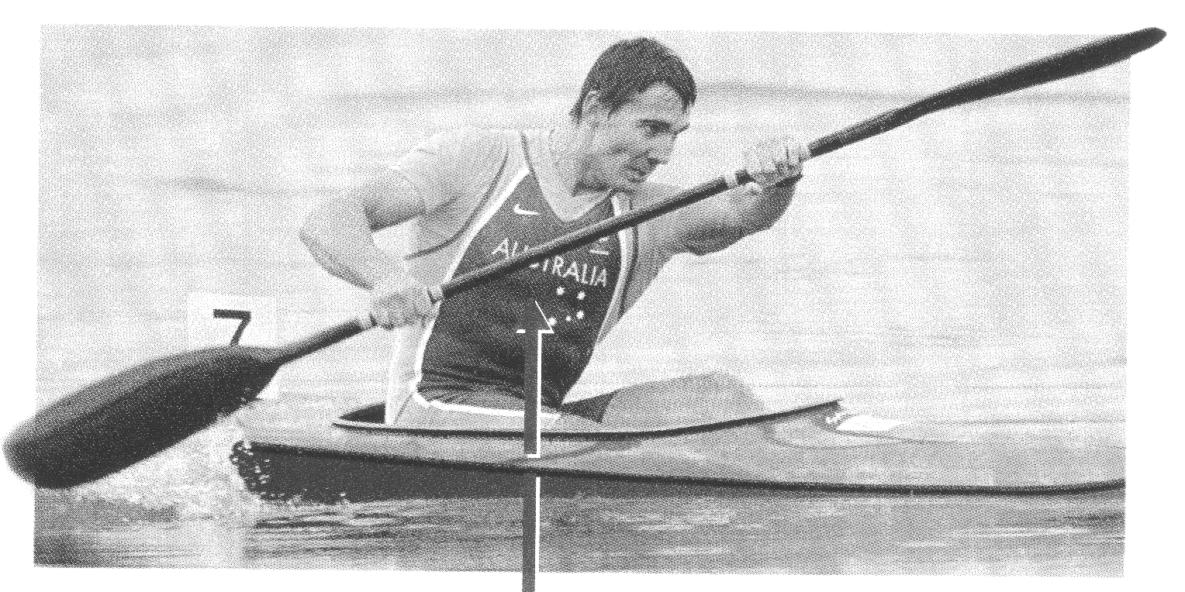
▼
The arrows describing these forces on the kayaker are even in length which means that the forces are the same size. These forces are acting in opposite directions, which means the force of the kayakers mass (called his weight) is pushing against the force of the water which is pushing up. These forces are balanced so he doesn’t move up or down.
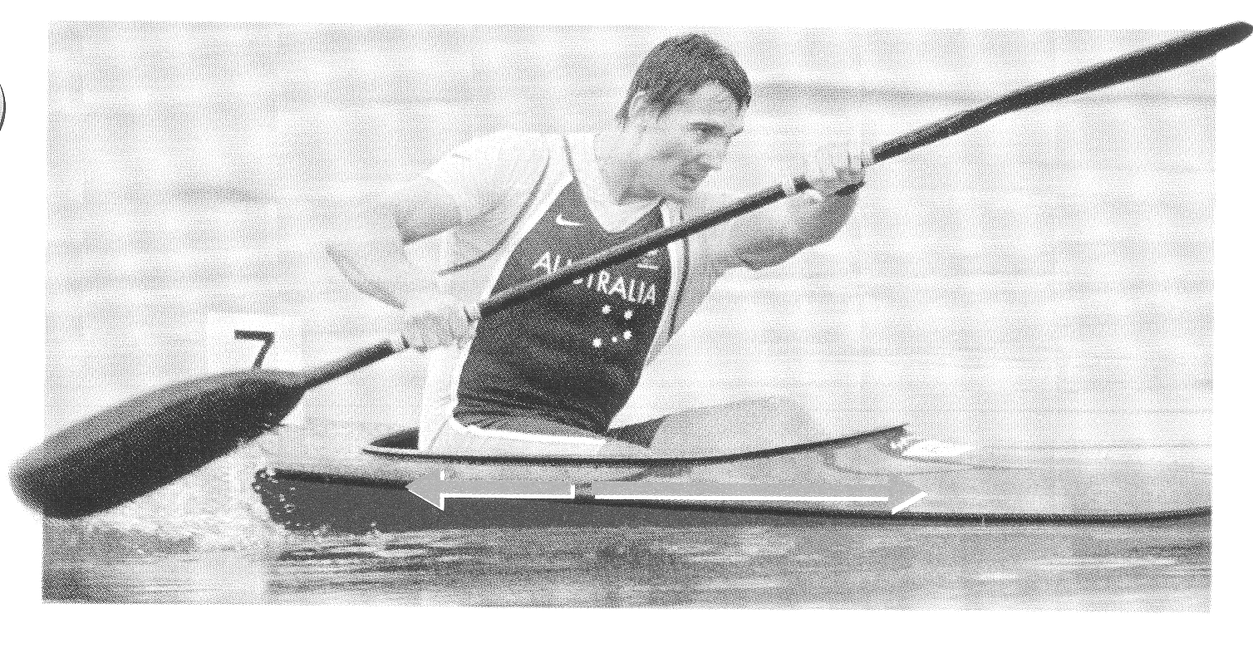
The lateral arrows are uneven in length which means the forces are uneven. The forward force is produced by the kayaker pushing his paddle in the water and this is greater than the force of drag (or friction) in the water so the kayaker moves forward in the water.
Everyday you experience forces on your body which push and pull you in a range of directions. These forces include that of the air pushing on you; which is surprisingly high; some 100 000 N for every square metre of body size (the average human body is approx. 0.8 m²). We call this air pressure and it is a measure of the force exerted per square metre of body area. As the force of gravity is pulling the air particles towards the earth’s surface then the air pressure is greatest closest to the surface and decreases as you rise through the atmosphere. Air pressure at the surface varies depending upon the air temperature and movements.

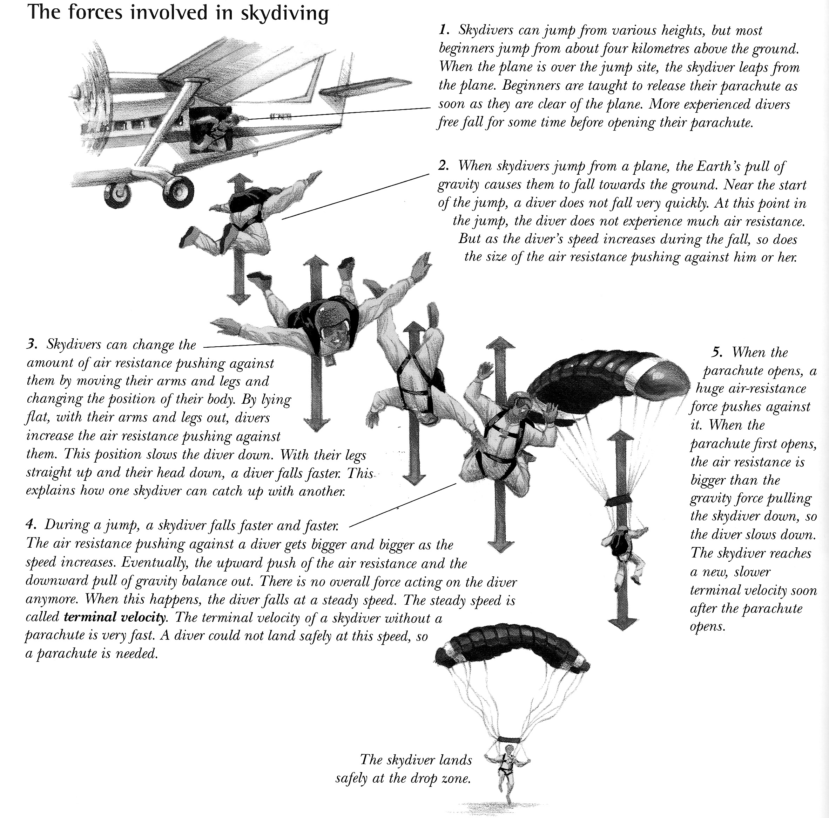
Similarly water particles push against your body exerting a considerable force when you are immersed underwater. The deeper you go the more water particles pushing down on your body so the greater the force. In fact for even 10 m of depth there is another 100 000 N pushing in on your body.

There are other forces acting on your body under the water too including the force of the diver’s mass (weight) and the force of the water pushing up on the diver (buoyancy). The following diagram shows some of these forces. When a diver has these forces all perfectly balanced it is called neutral buoyancy.
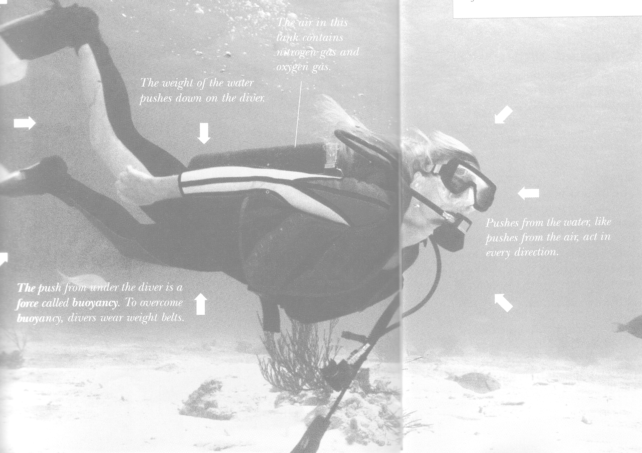

ANOTHER APPLICATION OF FORCES IN SPORT : SURFING
Read the following passage which describes how Layne Beachley uses forces to her advantage when surfing.
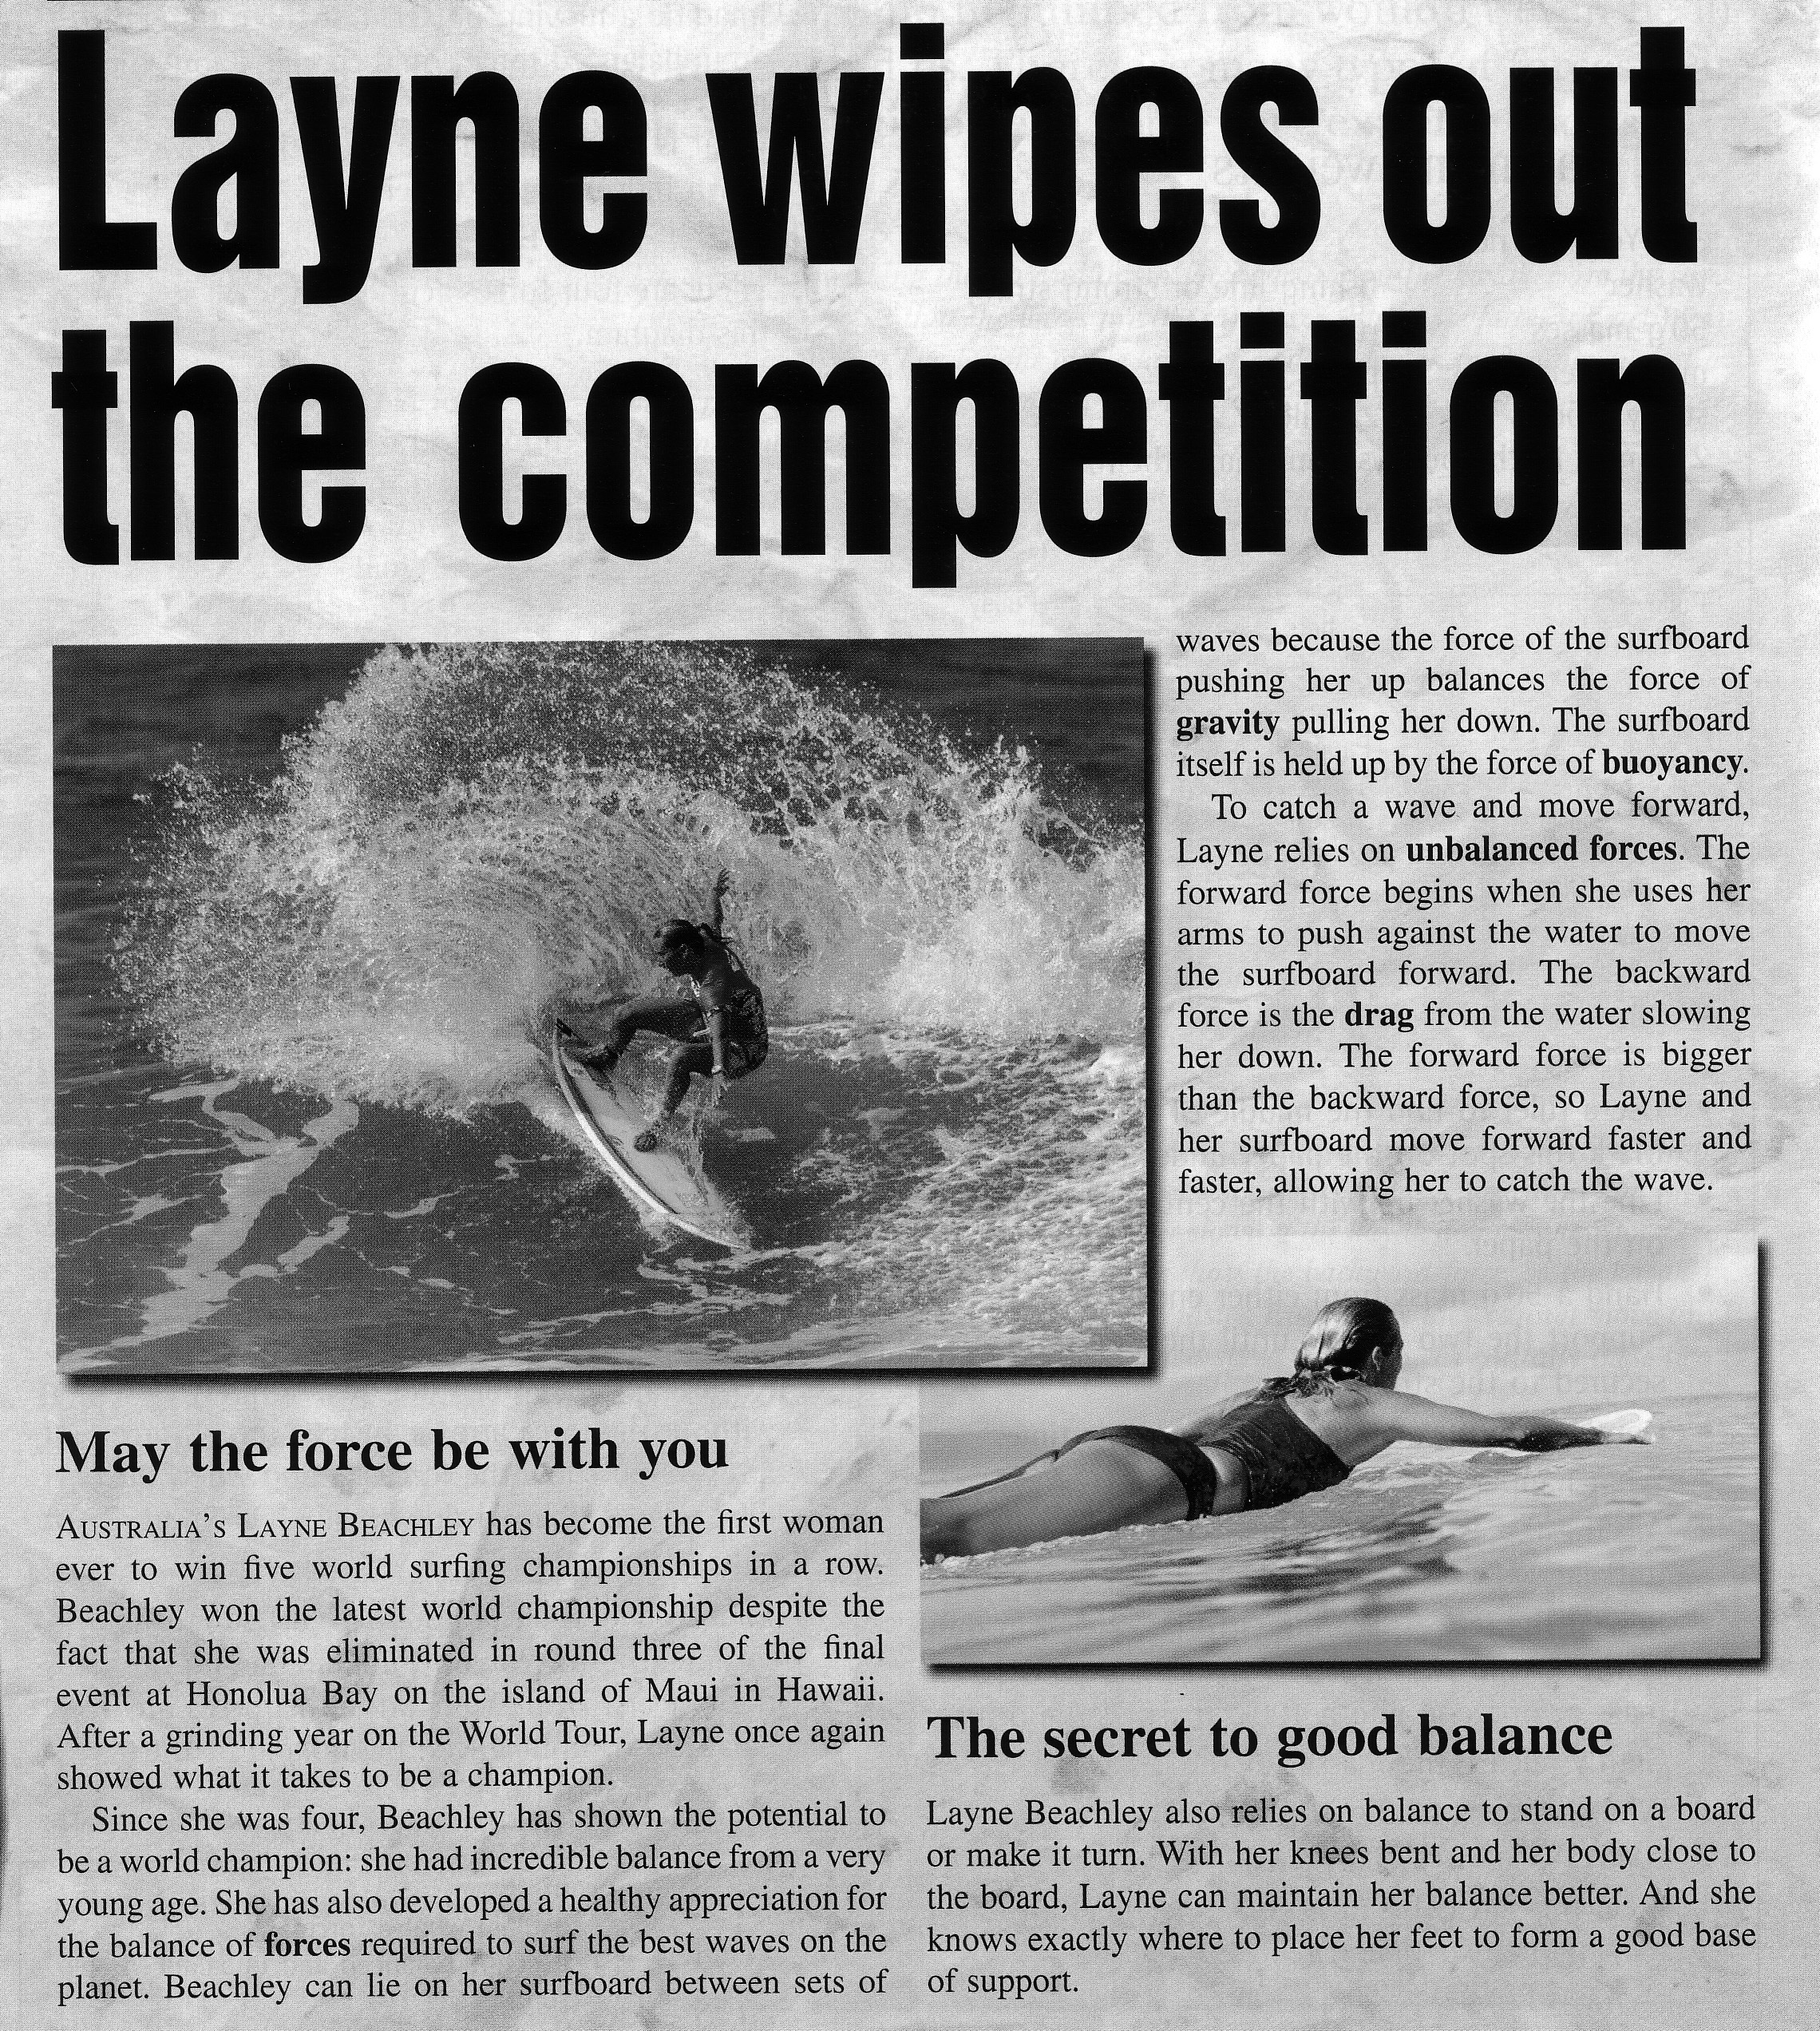
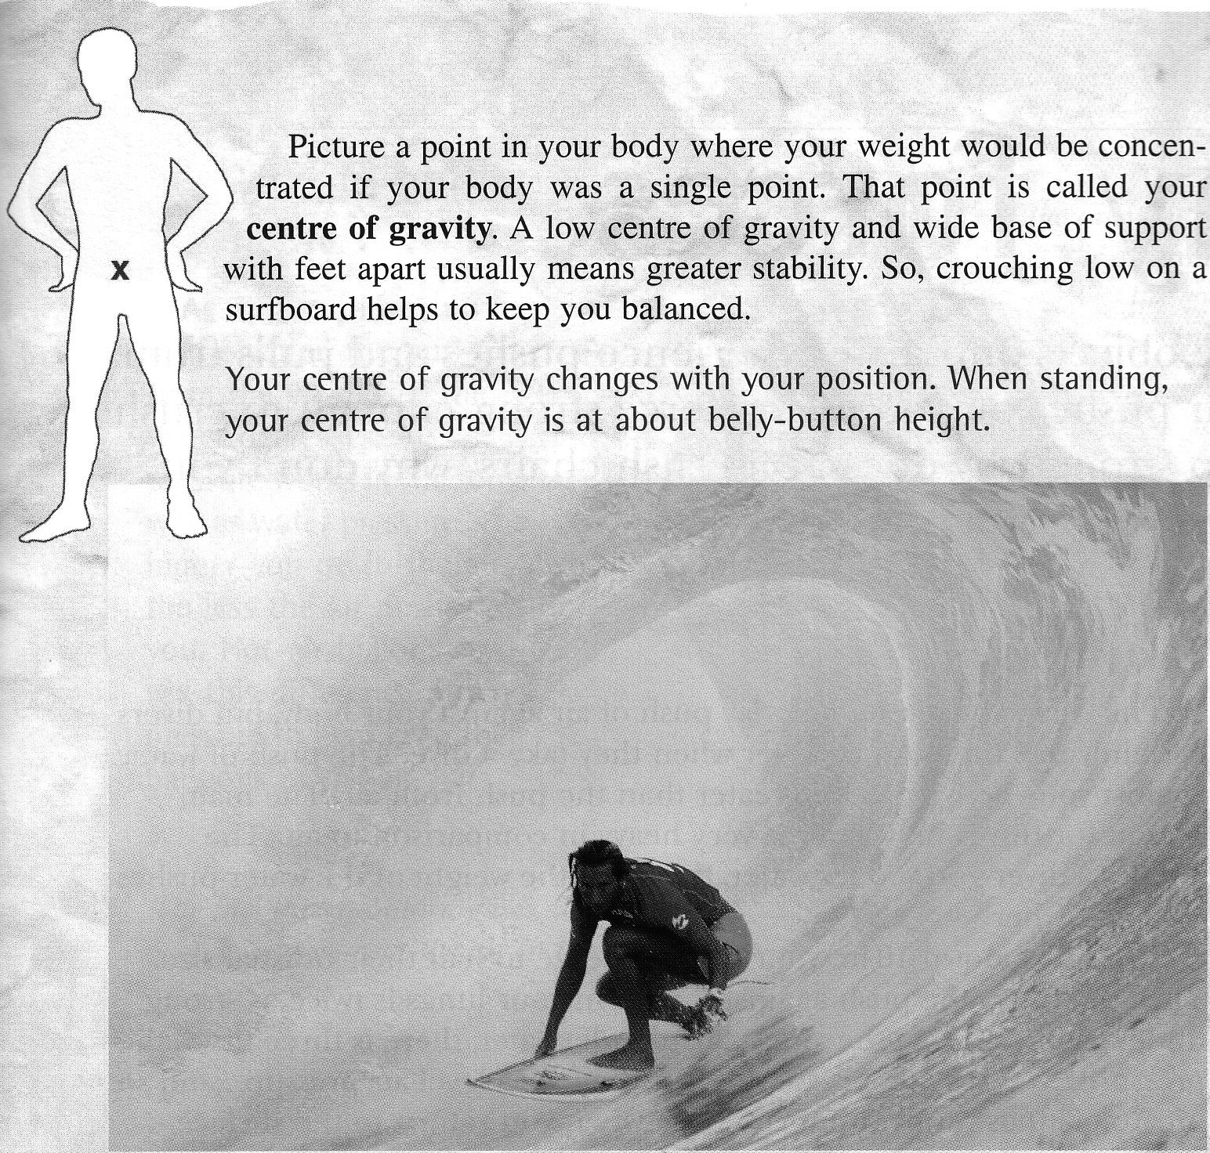 |  | Surfing is like skating downhill while being pulled uphill. The force of gravity pulls the surfer down the wave while the drag pulls the surfer back up the wave. Surfing is a fine balance between the forces of gravity, buoyancy and drag. The force of friction prevents the surfer from slipping off the surf board. Rubbing wax on to the deck of the board gives it a rough surface which in turn increases the force of friction. Friction is a force acting in the opposite direction to that in which the object is moving.  QUESTIONS:  1.Think about another sporting example where friction is useful. Describe the situation and explain how friction plays a role.  ___________________________________  ___________________________________  ___________________________________
2. There are 4 forces acting on the cyclist in this diagram.  i) Name the forces. __________________________  __________________________________________  ii) Which forces are balanced ? ________________  __________________________________________  iii) Which forces are unbalanced ? ______________  __________________________________________  iv) Is the rider’s speed increasing, decreasing or constant ?  __________________________________________ | 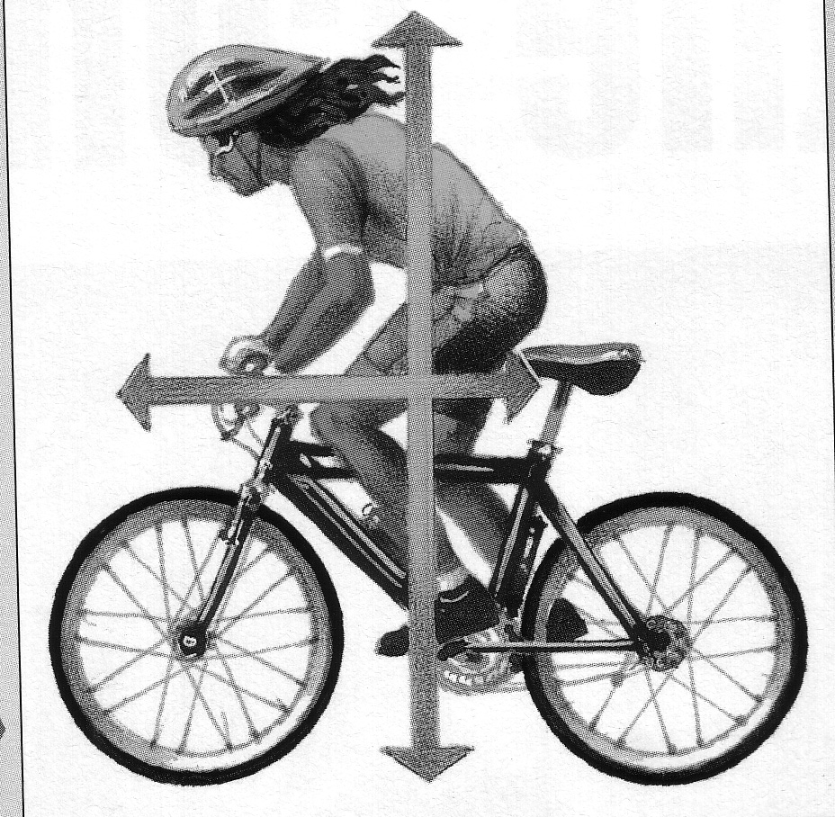

2.0 TIME & DISTANCE:
In order to measure speed we need to be able to measure time and distance accurately. Timing devices have undergone major changes in the past 100 years. In 1912 the accuracy of a stopwatch was 0.2 s, by 1932 it was 0.1 s however further improvement could not be made while relying on human judgement and reaction time. Reaction time is the time interval from when a stimulus is detected by the brain to when a response starts. Tests have confirmed that nobody can react in less than 0.110s.

Electronic timing was introduced was introduced in 1964 and increased accuracy to 0.01s and today’s computerised systems have an accuracy to 0.001s.

The SI unit for time is seconds or s. There are 60 seconds in a minute and 60 minutes in 1 hour; 24 hours in a day and 365.25 days in a year.

In the laboratory we use a stopwatch or clock to measure time. Other devices we will use ate the ticker timer which will be explained later.

In order to understand the way in which objects move we need to be able to time how long it takes for a distance to be covered. It is an important skill to be able to estimate distance and time using your common sense and experience.

Some useful ways of estimating length are to use a length of one pace which if you really stretch it out is approx. 1m, or use the length of your thumb from the tip to the first joint which is usually about 2.5 to 3 cm.

Estimating time is more difficult: traditionally we use the 1 cat-and-dog for a second. But estimating longer times can be challenging.

Activity 2.1: Estimations of Time

1 Estimate the time it would take:

a you to run 100 m as fast as you could

b Cathy Freeman to run 200 m

c to walk from room Sc 3.16 to the MLC Cafe

d to walk 1 km at a normal pace

2.1. DISPLACEMENT/ DISTANCE

Look at this diagram
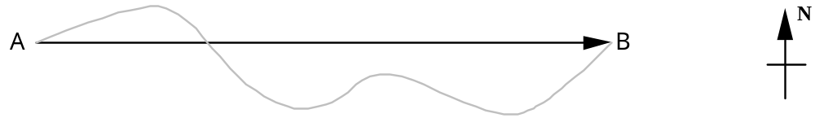

2.1 Distance is measured along the actual path followed. On the diagram this is the wavy line between A & B.

2.2 Displacement is defined as the straight line distance between the starting and finishing positions A & B and includes a direction.

2.3 The unit of distance and displacement usually used is the S.I. unit: the metre (m).

Example 1: A ball is thrown 5m vertically upward and caught again at the same height from which it was thrown.
Distance travelled = 10m; Displacement = 0m

Example 2
What is the resultant displacement of a person who walks 66m east and then 42m west.
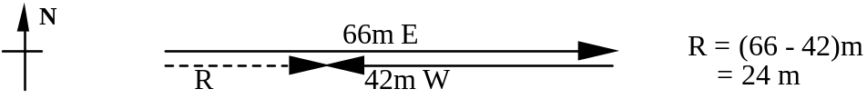
The resultant displacement is 24 m east.
Example 3

The dotted path represents the road between towns A and B and represents the total distance travelled.
Using a piece of cotton this measures 12 cm. The straight line AB represents the displacement in the direction of the line AB and is 10.2cm long.
If 1cm = 10 km then a car travelling from A to B would travel a distance of 120km. The car's displacement would be120km East.

2.2 DISTANCE AND DISPLACEMENT EXERCISES

Use diagrams to complete these problems on a sheet of paper.

Determine the distance travelled and the resultant displacement for the following situations:

1 A run of 52m south followed by a run of 164 m due south.
2 A netball thrown 5m directly down court and then thrown a further 6m in the same direction.
3 A swim of 65m north followed by a swim of 78m south.
4 A car travels 100km north east and then 50km south west.
5 A ball is dropped from a second storey window at a height of 5m. It bounces vertically upwards and is caught 1.5 m above the ground.
6 A bird flies 10km north then 10km west.
7 A horse starts a race at the northernmost part of a circular track. It does one lap which is 1km long.
8 The horse in the previous question then does half a lap.
( Hint: Circumference = ΠD)

Answers: 1) 216m; 216mS 2) 11m; 11m downcourt 3) 143m; 13m S 4)150km; 50kmNE 5) 6.5m; 3.5m down 6) 20km; 14.14kmNW 7) 1km; 0 8) 0.5km; 0.318km S

ACTIVITY 2.3: Distance / Displacement Exercise

Walk with a constant length pace so you follow these directions

Start at the southern end of the Great Court.
Walk 20 paces NORTH
Walk 20 paces WEST
Walk 5 paces NORTH
Walk 15 paces EAST
Walk 5 paces SOUTH
Walk 5 paces EAST. This is the finish point
Questions
1 What distance have you walked?

2 What is your displacement ? (distance and direction from the start point)

3 Choose an appropriate scale and draw a scale diagram of your journey.



4 Estimations of Length

Estimate the following:

a the longest wall in the physics classroom

b the length of bench in the physics classroom

c the area of a year 10 locker door

d the area of the cover of a year 10 physics text book

e the width of Connell Courtyard from the photocopy room to the science wall.

f the world record for the high jump

3.0. SPEED

3.1 Speed is the rate of change of distance of a body. The average speed is the distance moved per unit time,

Speed(av) = distance
time

Speed is a scalar quantity as it does not require any direction to be named.

3.2 The unit of speed is determined by using the formula, that is, dividing the units of length (m) by units of time (s),

metre = m = m.s-1 (or m/s )
seconds s

kilometre = km.h-1 ( or km/h)
hour

Example 1:

A girl can run 600 metres in 2 minutes. What is her average speed in metres per second?

Distance = 600m Average speed = distance
Time = 2 min = 120s time
Average speed = ? = 600
120
= 5m/s
Answer: The girl's average speed is 5m/s

2. If the journey took 35 min, what is the average velocity of the courier? (km h⁻¹)

3 If the journey took 35 min what is the average speed of the courier (km h⁻¹)

4 Would the average speed be the speed at which the courier was travelling for the whole journey ? Explain your answer.
3.3 EXERCISES

1 A toy car travels 5 metres in 4 seconds, calculate its average speed.
2 What is the average speed of a car which travels 250m in 15 s?
3 By how much is a car exceeding a 60 kilometres per hour speed limit if it travels 120 kilometres in 1.5 hours?
4 Calculate the average speed in metres per second of a rifle bullet which travels one kilometre in 0.5 seconds.
5 What is the average speed of a sprinter who runs 100m in 12.5 s ?
6 A body travels 36m in 4s. What is its average speed?
7 Determine the average speed (in kmh-1) of a plane which flies a distance of 720 km in 1.5 hours.

Answers: 1) 1.25m/s; 2) 16.7m/s 3) 20km/h; 4) 2000m/s 5) 8m/s 6) 9m/s 7) 480km/h
Example 2:

How long would it take a car travelling a speed of 80m/s to travel a distance of 25m?

Speed (av) = 80 m/s Average speed = distance
Distance = 25 m time
Time = ? Time = distance
average speed
= 25
80

Answer: The car would take 0.31 seconds

3.4 MORE EXERCISES
1 How long would it take a car travelling at 65m/s to travel a distance of 450m ?
2 A car travels a distance of 250 kilometres at 45 kilometres per hour. How long does it take to cover this distance ?
3 An aircraft travels at 500ms-1 between two towns. How long does it take to cover this distance if the towns are 30 km apart ?
4 How far will a bird fly in 25s travelling with an average speed of 6ms-1 ?
5 A person swims from one end of a pool to the other at an average speed of 1.5ms-1 in 20s. What is the length of the pool ?
6 Determine the distance travelled by a plane in 1 hour if it flies due south with a uniform speed of 90ms-1.
7 How long will it take for a body moving with a uniform speed of 7ms-1 to cover 98m ?
8 A cricket ball is thrown a distance of 90m from the boundary to the wicket at an average horizontal speed of 30ms-1. How long will it take for the ball to reach the wicket?
9 Determine the time taken for a horse running with an average speed of 14ms-1 to complete one circuit of a 840m track.
10 How long will it take to complete a trip from Perth to Kalgoorlie, a distance of 595 km, travelling at an average speed of 70kmh-1 ?
11 A train moving with an average speed of 80kmh-1 takes 0.25 hours to travel from one railway siding to the next. What is the distance between the two sidings ?

Answers: 1) 6.9s; 2) 5.5h; 3) 60s; 4) 150m; 5) 30m; 6) 324km; 7) 14s; 8) 3s; 9) 60s; 10) 8.5h; 11) 20km
4.0. VELOCITY

4.1. Velocity is the vector version of speed i.e. a direction is indicated as well. The formula is the same except that distance is replaced by displacement. The velocity of a body is the rate of change of displacement and a direction must be included.

The average velocity of a body can be found by:

Velocity(av) = displacement where vav = average velocity
time s = displacement
t = time interval

v = s
t

4.2. The unit of velocity is the same as for speed but a direction must be given with the answer.

Example 1:

Calculate the average velocity of a car which travels 300m east in 10 seconds.
s = 300m vav = s
t = 10s t
vav= ? = 300
10
= 30ms-1
The average velocity is 30 ms-1east

Example 2:

Determine the displacement of a body which moves with a uniform velocity of 2.4ms-1 for 50s.
vav = 2.4ms-1 vav = s
t = 50s t
s = ? s = vav x t
= 2.4 x 50
= 120m

The displacement is 120 m in the direction of the velocity.

4.3 EXERCISES HINT: Draw a diagram when completing these exercises.

1 A girl takes 100 seconds to walk 90m in an easterly direction. What is her average velocity ?
2 The girl in the above question runs back along the same path a distance of 50m. It takes 40 seconds to travel this distance.
(a) What is the total distance travelled and what is her displacement now ?
(b) What is her average speed and her average velocity for the entire trip?
3 A car travels 150 km south east in 2 hours and then 30 km north west in 15 mins. What was the (a) What is the total distance travelled and what is the car's displacement now ?
(b) What is the average speed for the entire trip?
(c) What is the average velocity for the entire trip?
4 A ball is dropped from a cliff, 20m above the ground and hits the ground 2 seconds later. It bounces and is caught at a height of 1m after 0.5 seconds.
(a) What is the total distance travelled and what is the ball's displacement now ?
(b) What is the average speed for the flight of the ball?
(c) What is the average velocity for the flight of the ball?
5 A person walks for 10s at 1ms-1 then for another 10s in the same direction at 2ms-1. Find the:
(a) total displacement.
(b) average velocity.
6 A body travels 200m at a uniform velocity of 4ms-1 and a further 150m in the same direction at a uniform velocity of 7.5ms-1. Determine the :
(a) total time taken
(b) average velocity for the whole journey.
7 A cyclist travels at 6ms-1 south for 10 minutes and then returns 600m along the same path. What is the final displacement of the cyclist ?
8 A runner runs a full lap of an 400m oval and finishes back where she started. What is her displacement and average velocity ?

Answers: 1) 0.9m/sE; 2) 140m; 40m east; 1m/s; 0.29m/s E; 3)180km;120kmSE;80km/h; 53.33km/hSE; 4) 21m;19m down; 8.4m/s; 7.6m/sdown;5) 30m in the direction of motion; 1.5m/s in the direction of motion; 6) 70s; 5m/s in the direction of motion; 7)3000m S; 8) 0; 0m/s in direction of motion.

5.0. USING THE TICKER TIMER TO DETERMINE CONSTANT VELOCITY

5.1 A ticker timer has an arm that vibrates up and down at a constant rate.
The arm causes a mark on the ticker tape when it hits a carbon paper disc.
If the tape is pulled through at a steady rate a row of equally spaced dots is produced. Equal spacing of dots represents uniform or constant velocity.
A body travelling at constant velocity covers the same distance in equal time intervals.

5.2 TICKER TAPE ANALYSIS

An object moving at constant velocity produced the following tape;

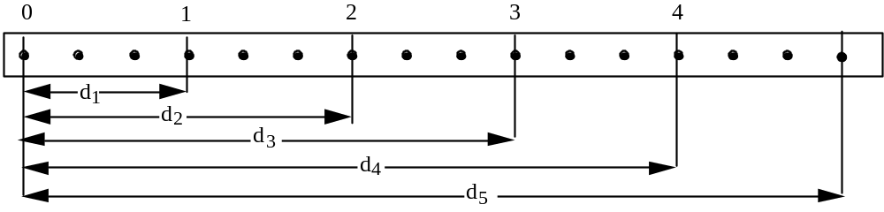

For this tape each dot was th ( one tenth) of a second apart so each space represents a time interval of th of a second.
The first marked interval (d1) represents a time interval of :
time interval = No. of spaces between dots x
t = 3 x
=
= 0.3 s

1. Measure with a ruler, the length of each marked interval
2. Record these lengths and the time that has passed, in the table below.
3. Calculate the speed and give the velocity for each interval and enter in the table.
4.
Marked  Interval | Distance (d)  cm | Time (t)  s | Speed  cm/s | Velocity  cm/s
d1

d2

d3

d4

d5

5. Construct a distance versus time line graph using information from the table.

Prepare a line graph from the information in the table, i.e., distance versus time.

6. What do the intervals between the dots mean ? __________________________________________

7. What does it mean if the dots are evenly spaced ? ---_______________________________________

8. What are we actually measuring with the ruler ? ____________________________________________

9. Constant velocity means the distance between equal time intervals _____________________________
5.3. AVERAGE SPEED FOR AN OBJECT TRAVELLING AT CONSTANT VELOCITY:

The distance, d5, and the time taken to travel that distance, are used to calculate the average speed for the whole tape. As the vehicle was travelling at constant speed this would be the same as the calculation of speed for any of the above intervals.
d5 = 15cm Average speed =
t5 = 15 x 0.1 = 1.5s =
= 10cm/s

5.4. TICKER TAPE ACTIVITY:

1.Using the ticker timer and ticker timer tape provided produce a tape which represents constant velocity.
2. Select and cut out a portion of tape where the intervals are evenly spaced.
3. Calculate the average speed of the vehicle for the whole tape. (As in d5 in the example)
NOTE: The period of the ticker timer which produced this tape was 0.02s.
4.Divide your tape into equal time intervals as done in the example.
5. Cut your tape along each line and paste the strips, in order, along the base line to make a bar graph.

___________________________________________________________________
Base line
As the length of each strip is a measure of the distance travelled in equal time intervals, the height of each strip represents the velocity of the vehicle in each time interval. This bar graph is equivalent to the velocity versus time graph (2) shown on next page.

6.0. GRAPHICAL REPRESENTATION OF VELOCITY

6.1. The graphs below,1 and 2, show constant or uniform velocity. In each case vav is equal to the velocity at any time. Graph 3 shows motion A with constant velocity, but motion B with varying velocity. Only for motion A is vav equal to the velocity at any instant, which is equal to the constant velocity.

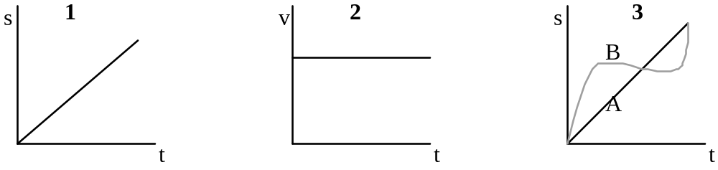

6.2. EXERCISES: GRAPH INTERPRETATION

1 The displacement - time graphs below describe the motion of different vehicles.
For each of these graphs, describe the motion that is occurring.
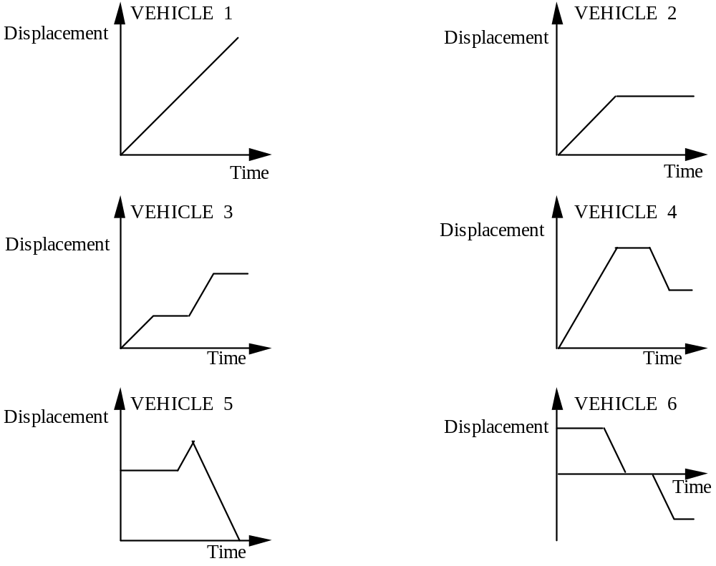

VEHICLE 1
________________________________________________________________________________

VEHICLE 2
________________________________________________________________________________

VEHICLE 3
________________________________________________________________________________

VEHICLE 4
_________________________________________________________________________________

VEHICLE 5
_____________________________________________________________________________

VEHICLE 6
_____________________________________________________________________________

2 Observation of a motor boat provides the following data:
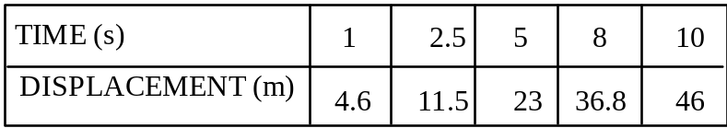
Draw a displacement - time graph to show this motion and use the graph to determine the:
(a) displacement after a - (i) 9s period
(ii) 6.4s period

(b) time interval to travel - (i) 15.3m
(ii) 35m

3 Stroboscopic photography of a fast bowler delivering a ball down a cricket pitch gave the following results:
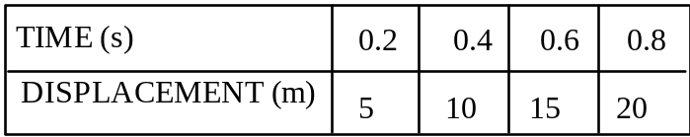
Draw a displacement - time graph to determine the:
(a) time taken to deliver the ball the length of the pitch, 20.1m.
(b) distance travelled by the ball in 0.35s

4 The graph below represents the motion of a toy electric car.
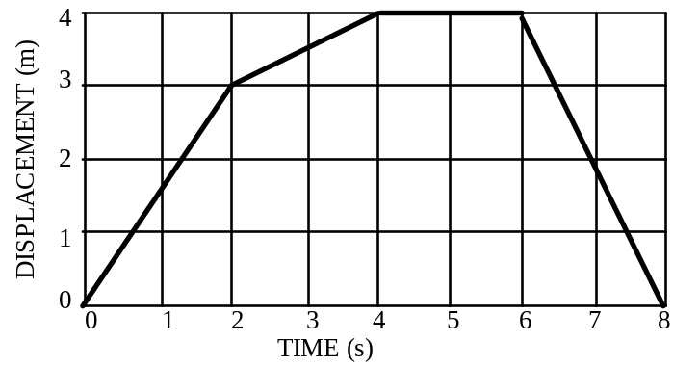

Use this graph to find:
(a) the velocity of the car - (i)in the first 2s
(ii)in the next 2s (i.e. between t = 2s and t =4s)
(b) in what time period the car was stationary
(c) the total displacement
(d) the average velocity for the 8s
(e) the total distance travelled
(f) the average speed for the 8s

5 A stone falling from rest provided the following data:
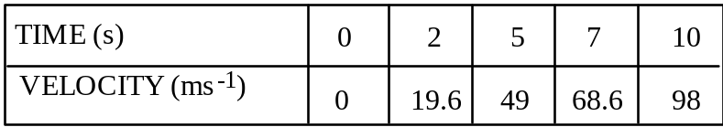

Construct a velocity-time graph to estimate the:

(a) velocity of the stone after - (i) 6.5s
(ii) 9s

(b) time taken to reach a velocity of (i) 17ms-1
(ii) 80ms-1

Answers: 2) 40m, 30m, 3s, 7.7s; 3) 0.82s, 8.75m; 4) 1.5m/s 0.5m/s, t=4 tot=6, 0, 0, 8m, 1m/s; 5. 68m/s in dom, 88m/s in dom, 1.8s, 8.1s

7.0. ACCELERATION

7.1. Acceleration occurs whenever the velocity of a body changes.
Acceleration is a vector quantity.
Acceleration is defined as the rate of change of velocity. The average acceleration of a body can be found by:

Average acceleration = change in velocity
time

= final velocity - initial velocity
time

a = v - u where v = final velocity
t u = initial velocity

7.2. Unit of Acceleration:
As acceleration is the rate of change of velocity then its units are those of velocity divided by time:

ms-1 = ms-2 (or m/s2).
s

NOTE: For a body starting from rest, the initial velocity, u = 0.
Assume any stated acceleration to be in the direction of the initial motion

Example 1:

A car starting from rest is accelerated at 2ms-2. Calculate the velocity after 5 s.

initial velocity, u = 0 (from rest) v -u = a x t
a = 2ms-2 v - 0 = (2 x 5 )
t = 5s = 10ms-1
final velocity, v = ?

The velocity is 10ms-1 in the direction of the acceleration.

Example 2

Determine the acceleration of a body which is accelerated from 2ms-1 to 10ms-1 in 2.5s.
initial velocity, u = 2ms-1 a = v - u
final velocity, v = 10ms-1 t
t = 2.5s = (10 - 2)
2.5
= 8
2.5
= 3.2 ms-2

Acceleration is 3.2ms-2( in the direction of the initial motion)

Example 3

What is the initial velocity of a body which attained a velocity of 16ms-1 when accelerated at 1.5ms-2 for 8s?
final velocity, v = 16ms-1 v - u = at
a = 1.5 ms-2 16 - u = (1.5 x 8)
t = 8s 16 - u = 12
initial velocity, u = ? u = 4ms-1

The initial velocity is 4ms-1( in the direction of the final velocity)

7.3. EXERCISES

1 What is the increase in velocity in each second of a body accelerated at 1.8ms-2?
2 Calculate the final velocity of a motor car initially travelling at 10ms-1 which is accelerated at 1.4ms-2 for 10 s.
3 A body starts from rest and is accelerated at 2.7ms-2. What is the velocity after 12s ?
4 A ball rolling down a slope from rest is accelerated at 3.5ms-2. What is the ball's velocity
after 6 s ?
5 Find the acceleration of a plane which increases its velocity from 100ms-1 to 200ms-1 in 40s.
6 What is the average acceleration of a body which is accelerated from rest to 15ms-1 in 5 s ?
7 Determine the average acceleration experienced by a body which increases its velocity from 7ms-1 to 34ms-1 in 9s.
8 A vehicle starting from rest is accelerated at 2.5ms-2 . Determine the time taken to reach a velocity of 5 ms-1 .
9 Find the time taken for a body travelling with a velocity of 15ms-1 to reach a velocity of 29ms-1 when accelerated at 0.7ms-2.
10 A car is accelerated from 10ms-1 to 25ms-1 in 2.5s. What is the average acceleration ?

Answers: 1) 1.8m/s; 2) 24m/s; 3) 32.4m/s; 4) 21m/s; 5) 2.5m/s2; 6) 3m/s2; 7) 3m/s2; 8) 2s; 9) 20s; 10) 6m/s2.

8.0. USING THE TICKER TIMER TO DETERMINE CONSTANT ACCELERATION

8.1. Constant acceleration occurs when a trolley rolls down an inclined slope under the influence of the force of _ _ _ _ _ _ _ . The drag-strip looks like this:

Start of motion 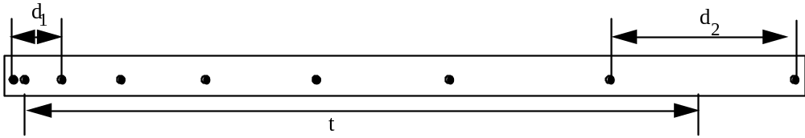

1. For this tape each dot was th ( one tenth) of a second apart so each space represents a time interval of th of a second.

2. Select a portion at the start of the tape and calculate the velocity. This is the initial velocity.

3.Select a portion at the end of the tape and calculate the velocity. This is called the final velocity.

4. The total time is the number of intervals between the centres of the portions over which the initial and final velocities were calculated.

5. Use the values obtained above to calculate the acceleration of the object which produced the tape above.

Initial Velocity  cm/s | Final Velocity  cm/s | Total Time  s | Acceleration  cm/s2

8.2. TICKER TAPE ACTIVITY :

1.Using the ticker timer and the ticker tape provided, produce a tape which represents constant acceleration.
.2. Select and cut out a portion of tape where the intervals are uniformly increasing.

3. Calculate the average acceleration for this portion.

NOTE: The period of the ticker timer which produced this tape was 0.02s.

4. Divide the tape into equal time intervals as done for the velocity activity.

5. Cut your tape along each line and paste the strips, in order, along the base line to make a bar graph.

___________________________________________________________________
Baseline

As the length of each strip is a measure of the distance travelled in equal time intervals, the height of each strip represents the velocity of the vehicle in each time interval. This bar graph is equivalent to the velocity versus time graph (2) shown on next page.

6. What can you say about the distance travelled during each time interval as time passes ? _______________
7. What can you say about the velocity of the trolley during each time interval as time passes? ____________

8. Is the velocity changing in a uniform way ? Explain. ____________________________________________

_________________________________________________________________________________________

8.3. REVISION :VELOCITY AND ACCELERATION TICKER TIMER TAPE ANALYSIS

The period (time between each dot) is 0.1 second.

(i)What type of motion does it represent ? ________________________________________

(ii) What is the average speed of the object producing this tape ? (Use a ruler to measure distances.)
____________________________________________________________________________________________________________________________________________________________________________

2. The tape below is for a trolley accelerating from rest. The period is 0.03second.

(i) What is the average speed of the trolley during the section of the tape above ?
____________________________________________________________________________________________________________________________________________________________________________

(ii) What is the acceleration of the trolley ?
______________________________________________________________________________________

______________________________________________________________________________________

______________________________________________________________________________________

9.0 NEGATIVE ACCELERATION

9.1. If a body travelling in a positive direction slows down uniformly, the final velocity is going to be less than the initial velocity.

Using the equation: a = v - u
t

will give a negative value for acceleration because the acceleration is in the opposite direction to the velocity.
Negative acceleration is also known as deceleration or retardation.

9.2. SIGN CONVENTION FOR VECTOR MOTION IN ONE STRAIGHT LINE

1 Take the direction of initial motion to be positive. All vectors in this direction will be given a positive value.

2 If, in a calculation, an acceleration is found to be:

(a) positive, then it is in the direction of initial motion and velocity increases uniformly.

(b) negative, then it is in the opposite direction to the initial motion and velocity decreases uniformly.

Example 1:

A car is uniformly slowed down from 26ms-1 to 6ms-1 in a period of 8s.

Calculate the acceleration of the car.

initial velocity, u = 26ms-1 a = v - u
final velocity, v = 6ms-1 t
t = 8s = (6 - 26)
a = ? 8
= -20
8
= -2.5ms-2

Acceleration is -2.5ms-2 or retardation is +2.5ms-2, and is in the opposite direction of the initial motion.

9.3. EXERCISES

1 A train approaching a railway station at 30ms-1 is brought to rest in 10s. Determine the retardation.
2 A plane on landing touches down at a speed of 80ms-1. Determine the acceleration if the plane comes to rest in a time of 8s.
3 A truck travelling at 36ms-1 is decelerated uniformly at 1.5ms-2. Calculate the:
(a) velocity after 6s.
(b) time taken to come to rest.
4 A plane flying at 170ms-1 slows down uniformly at 2ms-2. What is the plane's velocity after 30s?
5 How long will it take a vehicle travelling at 30ms-1 to reach a velocity of 12ms-1 if the acceleration is -3ms-2 ?
6 A bus travelling at 25ms-1 is decelerated at 2.5ms-2 . Find the time taken for the bus to come to
rest.
7 A motor cyclist brakes suddenly with a uniform acceleration of -4ms-2 and comes to rest in 2.5s. Determine the initial velocity of the cyclist.

Answers: 1) 3m/s2; 2) -10m/s2; 3) 27m/s, 24s; 4) 110m/s; 5) 6s; 6) 10s, 7) 10.0m/s

10.0. GRAPHICAL INTERPRETATION OF ACCELERATION
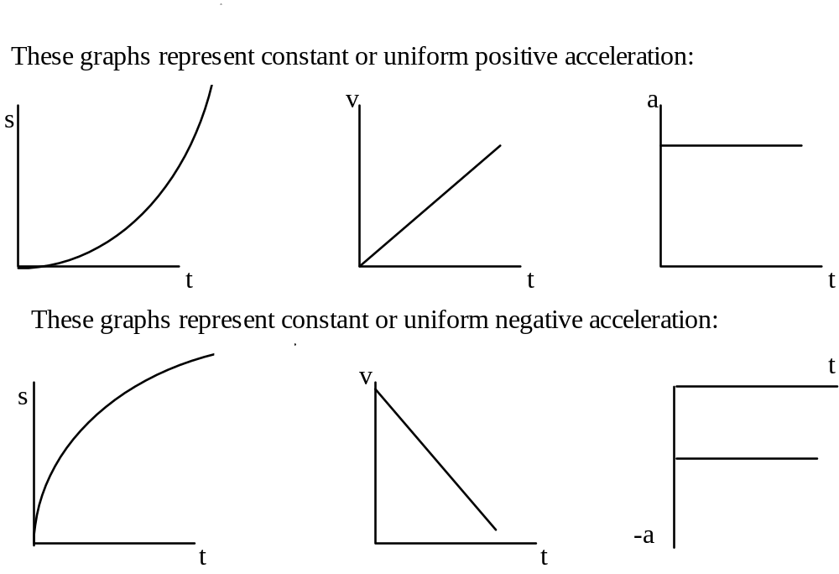

10.1. EXERCISES

1 The velocity - time graphs below describe the motion of different vehicles.
For each of these graphs, describe the motion that is occurring.
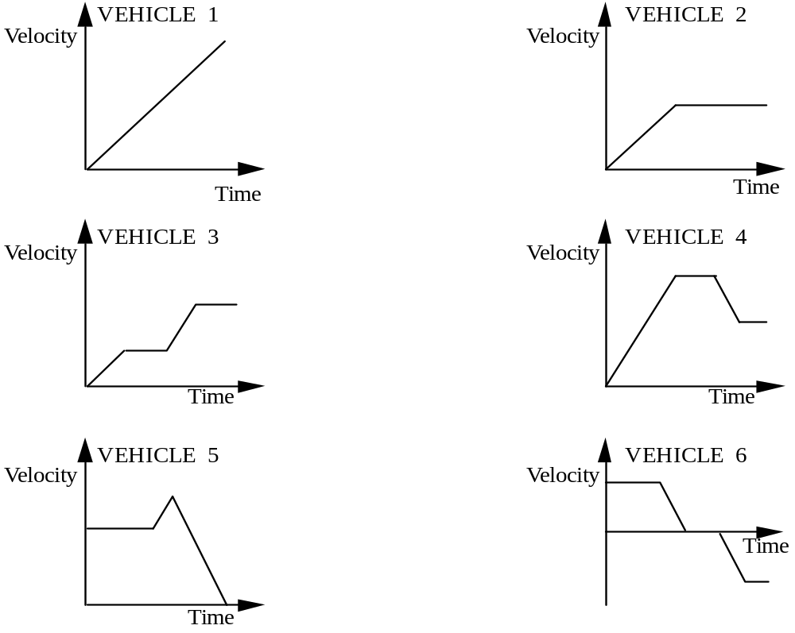

VEHICLE 1: __________________________________________________________________

VEHICLE 2: ___________________________________________________________________

VEHICLE 3: ___________________________________________________________________

VEHICLE 4: ___________________________________________________________________

VEHICLE 5: ___________________________________________________________________

VEHICLE 6: ___________________________________________________________________

2 A short aeroplane journey is represented by the following graph:

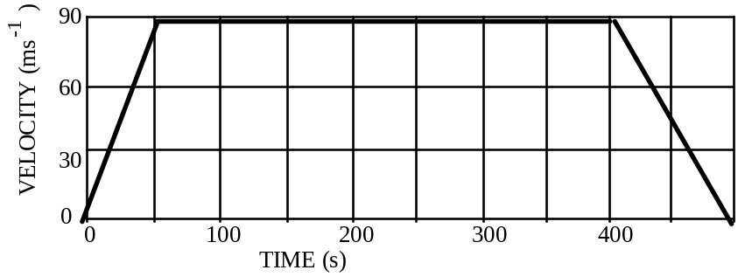

Use the graph to find the:
(a) velocity after 50s
(b) acceleration during the first 50s
(c) displacement while travelling at a constant velocity
(d) acceleration for the first 100s of the journey.

3 The motion of an object is represented by the graph:
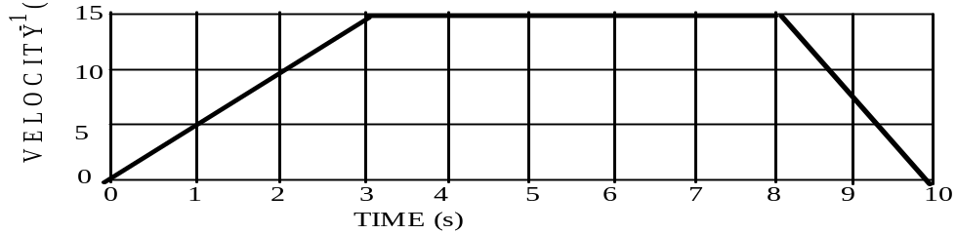
(i) During what times was the object accelerating (+ve acceleration) ?
(ii) During what times did the object experience 0 acceleration ?
(iii) What is the acceleration during the first 3 seconds ?
(iv) What is the acceleration during the 8 - 10 second interval ?

4 The motion of an object is represented by the graph:

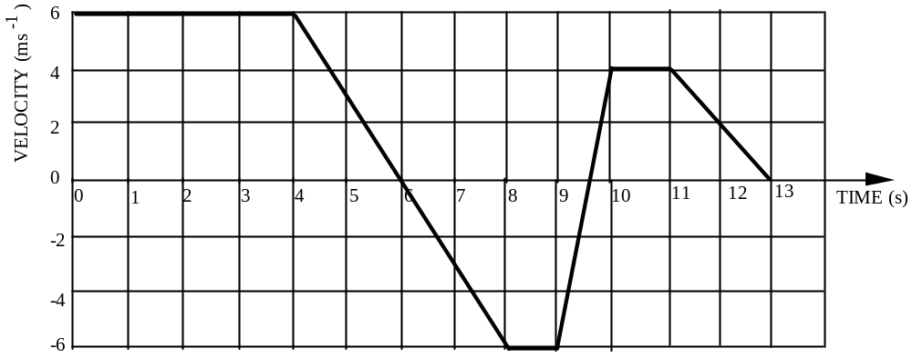

(i) During what times did the object experience 0 acceleration ?
(ii) What is the acceleration during the 10th second ?
(iii) What is the acceleration between 11 - 13 seconds ?
(iv) What is the body's acceleration at t = 6 seconds ?

Answers: 2) 90m/s, 1.8m/s2, 31500m, 0.9m/s2; 3) t=0 to t=3,t=8 to t=10, t=3 to t=8, 5m/s2, -7.5m/s2; 4) t=0 to t=4, t=8 to t=9, t=10 to t=11, 10m/s2, -2m/s2, -1m/s2;

Another formula you may find useful when calculating velocity of a uniformly accelerating object is

v² = u ² + 2 as

NEWTON'S LAWS OF MOTION

Isaac Newton published a work in 1687 called the Principia which helped to explain how things move. These ideas were accepted for more than 200 years until the early 20th century when Einstein proposed a different theory of motion called the general theory of relativity. While it is now accepted that Einstein’s theories give a better explanation of motion in extreme situations such as travelling at the speed of light or for extremely heavy objects; there is no difference in the predicted motion of objects in everyday situations so Newton’s Law’s of Motion are still used today. Newton’s first 2 Laws explain how things accelerate while the third law explain how actions and reactions are related.

1.0 NEWTON'S FIRST LAW OF MOTION

1.1 Every mass stays at rest or moves at constant speed in a straight line unless a resultant force acts on it. This means that objects will only change the way they are moving if they are acted on by an unbalanced force. This is also known as the law of inertia.

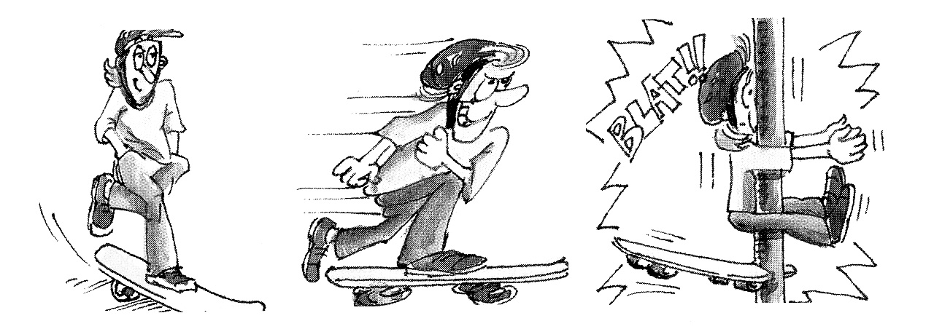
A force may be defined as that which produces or tends to produce a change in the state of rest or motion of a body. The bigger the mass, the bigger the force that is needed. This reluctance to move is called inertia.
Inertia depends on the mass of an object and will be the same wherever it is, out in space, on the moon or on the earth. Likewise when an object is moving it is just as hard to stop, as its inertia keeps it moving.
A car travelling at even a low speed such as 40 kph has a lot of inertia. So do the occupant in the car. If the car travelling at 40kph stops suddenly then the occupants keep moving due to inertia. Without restraints they would be thrown through the windscreen or into the seat in front. This is why it is compulsory to wear a seat belt. The seat belt exerts enough force on the passenger to stop them from continuing to move.

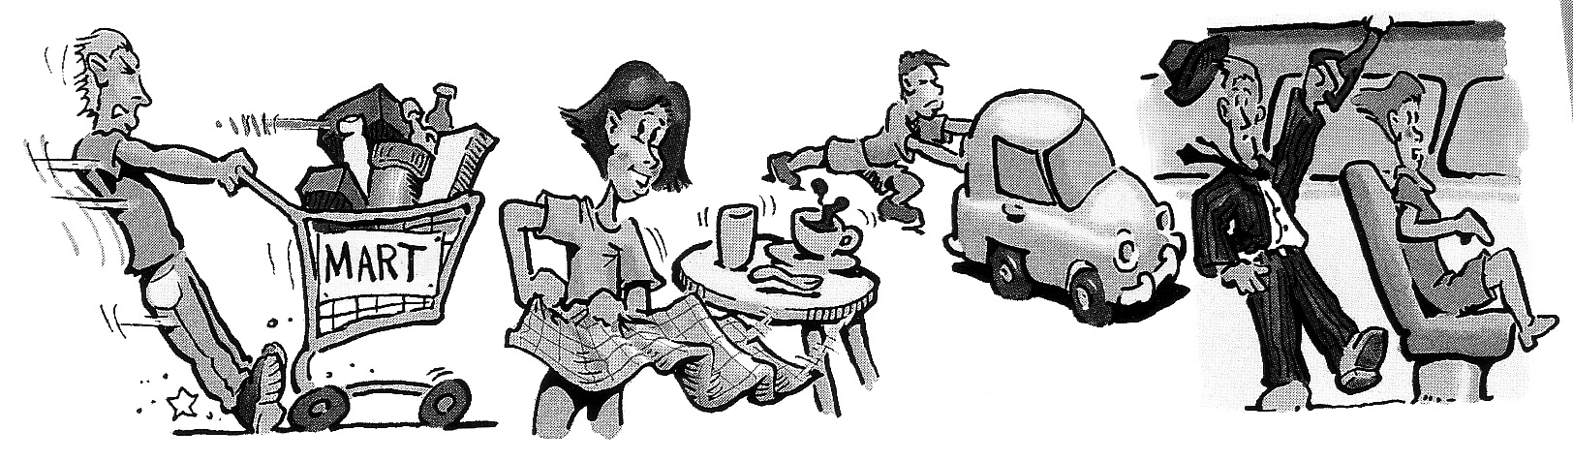
A B C D
For each of the above diagrams explain the effects of inertia demonstrated.

A ____________________________________________________________________________________

B ____________________________________________________________________________________

C ____________________________________________________________________________________

D ____________________________________________________________________________________
2.0 NEWTON'S SECOND LAW OF MOTION

2.1. When an unbalanced force acts on a body which is free to move, it produces an acceleration in the direction of the force. The acceleration is directly proportional to the applied force and inversely proportional to the mass of the body.

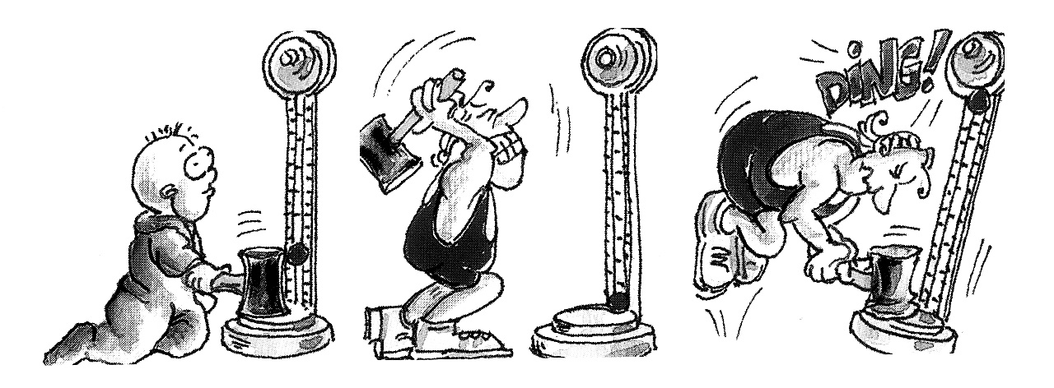

In other words a small force produces a small acceleration while a large force produces a large acceleration.

2.2. Mathematically this law can be expressed as:

Force = mass x acceleration

or F = ma where F, m and a are expressed in S.I. units

2.3. The unit of force is the Newton (N) and is defined such that a net force of 1Newton acting on a mass of 1 kilogram produces an acceleration of 1ms-2

Example 1 :

An unbalanced force causes a mass of 15 kilograms to accelerate at 3 metres per second squared. What is the size of the unbalanced force ?

mass = 15kg Force = mass x acceleration
acceleration = 3ms-2 = 15 x 3
= 45N

Example 2 :

An unbalanced force of 200N causes an object to accelerate at 4ms-2. What is the mass of the object ?
F = 200N F = m x a
a = 4ms-2 200 = m x 4
= 50kg

Example 3:
An unbalanced force of 150N acts on a 30kg mass. What is the object’s acceleration?
F = 150N F = m x a
m =30kg 150 = 30 x a
= 5ms-2

2.4. EXERCISES

1 A mass of 6 kg is accelerated at 3.5ms-2. What net force is applied?
2 Determine the magnitude of the force which when acting on a mass of 2.5kg produces an acceleration of 5ms-2.
3 What force must act on a car of mass 2 000kg to produce an acceleration of 1.6ms-2 ?
4 Find the acceleration produced when a force of 200N acts on a body of mass 40kg.
5 A force of 36N acts on a 24kg mass. What acceleration is produced ?
6 What acceleration is produced when a net force of 16N acts on a mass of 48kg ?
7 Determine the acceleration resulting when a force of 625N acts on a body of mass 125kg ?
8 A force of 72N produces in a body an acceleration of 1.2ms-2 . What is the mass of the body ?
9 What is the mass of a car which is accelerated at 2ms-2 when acted on by a force of 2 800N ?
10 A force of 3N is applied to a block on a smooth horizontal table and produces an acceleration of 11ms-2. What is the mass of the block ?

Answers: 1) 21.0N; 2) 12.5N; 3) 3200N; 4) 5m/s2; 5) 1.5m/s2; 6) 0.33m/s2; 7) 5m/s2; 8) 60kg; 9) 1400kg; 10) 0.26kg.

2.5. EXERCISES INVOLVING MORE THAN ONE FORMULA:

Example 1:

1 A stationary mass of 5kg is acted on by a force of 50N.
a) What is the velocity after a period of 3s ?
b) What is its displacement after this time ?

a) m = 5kg F = ma
F = 50N 50 = 5 x a
u = 0 a = 10ms-2
t = 3s v - u = at
v = ? v - 0 = 10 x 3
v = 30m/s

b) s = ut + at2
= (0 x 3) + ( x 10 x 32 )
s = 45m

Example 2:
Determine the force that accelerates a 4kg mass from rest to 21m/s in a time of 3s.

u = 0 a =
v = 21m/s a =
t = 3s a = 7ms-2
m = 4kg F = m x a
= 4 x 7
= 28N

2.6 EXERCISES .

1 A force of 60N acts on a mass of 30kg initially at rest. What is the velocity after a period of 8s ?
2 A stationary mass of 12kg is acted on by a force of 15N for 6s. Determine the:
(a) final velocity
(b) resulting displacement.
3 A body of mass 6.5kg initially moving at 7.5ms-1 is acted on by an accelerating force of 19.5N for 1.5s. Calculate the:
(a) final velocity
(b) displacement
4 Determine the force which will accelerate a body of mass 4.5kg from rest to 7.5ms-1 in 5s.
5 A vehicle of mass 1 250kg is accelerated from 6.5ms-1 to 19.5ms-1 . Determine the force which is required to produce this change in 2s.
*6 What force acting on a body of mass 16kg initially at rest, will produce a displacement of 875m in 5s ?

Answers: 1) 2m/s2, 16m/s; 2) 1.25m/s2, 7.5m/s, 22.5m; 3) 3m/s2, 12m/s, 14.625m; 4) 1.5m/s2 6.75N; 5) 6.5m/s2, 8125N; 6) 70m/s2 , 1120N.

2.7. A special case of acceleration: Falling Bodies

Mass refers to ____________________________________________________ and is measured in_________________(S.I.) Weight is a______________________ and is directed ______________________. As weight is a force it is measured in______________.

Freely falling bodies are accelerated at ______ , g, near the earth's surface.
So a mass of 1kg falling freely near the surface of the earth will be accelerated at 9.8ms-2.
The gravitational force of attraction producing this acceleration is:

F=ma
= 1 x 9.8
= 9.8N which is, by definition, the weight of a mass of 1kg.

Newton's Second Law can also be used to find the gravitational force of attraction, or weight on a mass:

Fw = mg

Example 1:

At a certain place on Earth the gravitational acceleration is 9.8ms-2.What is the weight of a 5kg body at this location ?

m = 5kg Weight = mass x gravitational acceleration
g = 9.8ms-2 = 5 x 9.8
= 49.0N

2.8. EXERCISES

Use g = 9.8ms-2 for acceleration due to gravity near the earth's surface.

1 What is the weight of a:
(a) 52kg mass (b) 2.6kg mass ?

2 Determine the mass of bodies with the weights:
(a) 350N (b) 5N

3 Find the weight of a student of mass 48kg.

4 What is the weight of a 1000kg motor car?

5 What is the mass of a crate which weighs 1200N ?

6 A vehicle of mass 800kg has a horizontal force equal to its weight applied to it. Find the:
(a) weight of the vehicle
(b) acceleration produced

7 A body of mass 4kg at rest is acted upon by a force equal to half its weight. Determine after 3s, the:
(a) velocity
(b) displacement

8 A body is suspended on a spring balance and shows a weight of 20N. This same balance and body on the surface of the moon would show 3.2N. What is the acceleration due to gravity on the surface of the moon ?

Answers: 1) 520N, 26N; 2) 35kg, 0.5kg; 3) 480N; 4) 10 000N; 5) 120kg; 6) 8000N; 10m/s2; 7) 40N, 5m/s2, 15m/s, 22.5; 8) 2kg, 1.6m/s2.

MOMENTUM:
The heavier an object is the harder it is to stop. The faster an object is travelling, the harder it is to stop. This property of moving bodies is called momentum and is expressed mathematically as follows.

Momentum (kg.m/s) = mass (kg) x velocity (m/s)

The greater the momentum of a body the harder it is to stop.

Explain how the top two diagrams are demonstrating inertia:

____________________________________________________________________________________

____________________________________________________________________________________

____________________________________________________________________________________

____________________________________________________________________________________

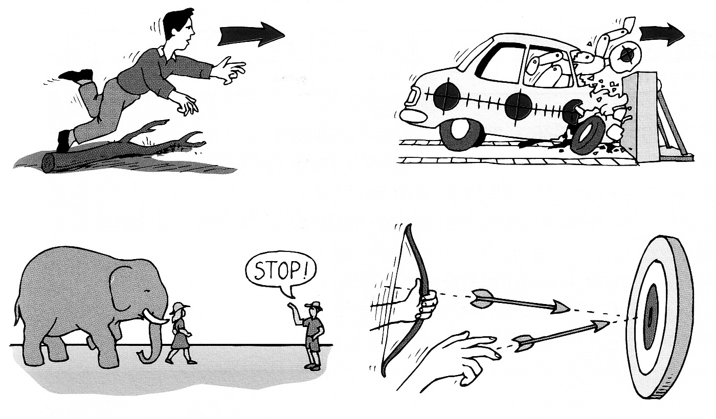
ii) Explain how these bottom 2 diagrams are demonstrating momentum

____________________________________________________________________________________

____________________________________________________________________________________

____________________________________________________________________________________

____________________________________________________________________________________

3.0. NEWTON'S THIRD LAW OF MOTION

Whenever a body exerts a force on another body (action force) this second body exerts a force equal in magnitude but opposite in direction on the first.(reaction force)
Forces always occur in pairs. For every action there is always an equal but opposite reaction.

For example:
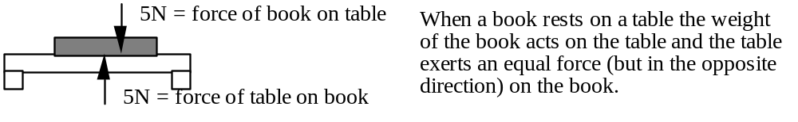

However:
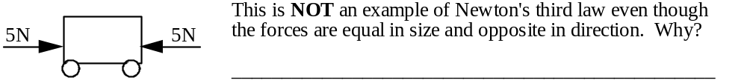

In the following situations, identify the action and reaction forces involved:
1. Hitting a ball with a tennis racquet. ______________________________________________________________________________________ ______________________________________________________________________________________
2. Rocket propulsion
______________________________________________________________________________________ ______________________________________________________________________________________
- Operation of a skateboard
______________________________________________________________________________________ ______________________________________________________________________________________
4. Shooting a rifle
______________________________________________________________________________________ ______________________________________________________________________________________
5. Starting blocks for runners
______________________________________________________________________________________ ______________________________________________________________________________________
6.
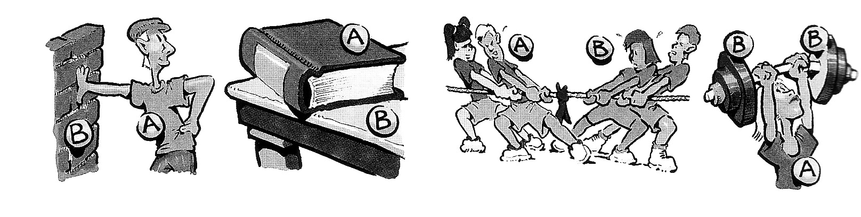
i ii iii iv
i ____________________________________________________________________________________

ii ____________________________________________________________________________________

iii ____________________________________________________________________________________

iv ____________________________________________________________________________________
4.0 ENERGY

Energy is defined as the capacity to do work. Work is a measure of the amount of useful energy transformed from one form to another.
Unit of Energy: The S.I. unit of energy is the _ _ _ _ _ (J), the same as the unit for _ _ _ _.

Energy can exist in many forms. Energy cannot be seen but can be detected when it changes from one form to one or more other forms of energy. There are two main types of energy; kinetic (or the energy associated with motion) and potential energy (or stored energy).

4.1 KINETIC ENERGY
Kinetic energy is _________________________________________________________________

The kinetic energy of a body can be found using the formula: EK = 1/2mv2

EXAMPLE
What is the kinetic energy of a 1000kg car moving at 20m/s (72km/h) ?
m = 1000kg EK = 1/2mv2
v = 20m/s = 1/2 x 1000 x (20)2
= 200 000J

When work is done, energy is being converted from one form to another. ________________ energy is being converted to kinetic energy in a car. The car may increase or decrease its speed.

The work done on a body will be equal to its change in kinetic energy:

Work done = Difference in EK = EK (final) - EK (initial) = 1/2mv2 - 1/2mu2

If the energy change is positive then there has been a _______ in kinetic energy and an ___________ in its velocity; if it is negative then there has been a _______ in kinetic energy and a ____________ of velocity.

EXAMPLE
How much heat and sound energy will be produced when a bullet of mass 1g travelling at 400ms-1 strikes and comes to rest in a wooden target ?
The ________________ energy of the bullet will be converted to heat and sound.

m = 1g = .001 kg Difference in energy = 1/2 mv2 - 1/2mu2
u = 400ms-1 = [1/2 x 0.001 x (0)2 ] - [1/2 x 0.001 x (400)2]
v = 0 ms-1 = - 81.19J
EK = ? Loss in EK = 81.19J

The heat and sound energy produced will be 81.19 J

KINETIC ENERGY EXERCISES

1. Calculate the kinetic energy of a 50kg mass moving at a speed of 5ms-1 .
2. What is the kinetic energy of a bullet of mass 2g travelling at a speed of 250ms-1 ?
3. What is the mass of an object possessing 200J of kinetic energy and travelling at a velocity of 5ms-1 ?
4. Determine the velocity of an aeroplane of mass 1 000kg which has a kinetic energy of
5 000 000J.
5. A metal ball of mass 4kg moves along a smooth horizontal surface at 3ms-1 .
What loss in kinetic energy occurs in bringing the ball to rest ?
6. How much work must be done to stop a car of mass 1500kg moving at 10ms-1 ?
7. A body of mass 25kg is accelerated from rest to 40 ms-1 . What is the gain in kinetic energy ?
8. How much work must be done on a motor cycle of mass 250kg to accelerate it uniformly from rest at 3ms-2 for 4s ?
9. What is the gain in kinetic energy of an object of mass 40kg if it falls from rest for 4s ?
10. What loss of kinetic energy occurs as the speed of a bicycle is reduced from 12ms-1 to 4ms-1 ? The mass of the bicycle and cyclist is 100kg.

Answers: 1. 625J; 2. 62.5J; 3. 16 kg; 4. 100ms-1; 5. 18J; 6. 75000J; 7. 20000J; 8. 12ms-1; 18000J; 9. 40ms-1; 32000J 10. 6400J.

4.2 POTENTIAL ENERGY (PE or E_{p})
There are many forms of potential energy including elastic PE, electrical PE, chemical PE and nuclear PE but the one we will deal with specifically is gravitational potential energy. Whenever an object is lifted from the ground, work is being done against gravity. This work is converted to gravitational potential energy which is stored by the object due to its position in Earth's gravitational field. Potential energy can be found using the formula:

EP = mgh

EXAMPLE
A rock of mass 5 kg is dropped from a window. Its velocity upon impact with the ground is 20ms1.

Determine the: a) EK at the time of impact
(b) gain in EK
(c) loss in potential energy of the rock.
(d) height of the window.

(a) m= 5kg EK = 1/2 mv2
u = 0 = 1/2 x 5 x (20)2
v = 20ms-1 = 1 000J
Kinetic energy at impact is 1000J

(b) Gain in EK = EK (final) - EK (initial) = 1/2mv2 - 1/2mu2
As u=0, Gain in EK = 1/2mv2 which we found in (a)
= 1 000J
Gain in Kinetic Energy is 1000J

(c) Loss in EP = Gain in EK = 1 000J, found in (a)
Loss in Potential Energy is 1 000J

(d) m= 5kg EP = mg( h2- h1)
g = 10ms-2 h2- h1 =
h1= 0 (ground level) h2 - 0 =

h2 = ? h2 = 20m
EP = 1 000J The height of the window is 20m.

POTENTIAL ENERGY EXERCISES

1. A rocket of mass 25kg reaches a height of 500m before beginning its fall back to earth. What is its maximum potential energy ?
2. A drum of mass 80kg is rolled up a ramp onto the back of a truck, 1m above the ground. What is its gain in potential energy ?
3. How much work is required to lift a bag of wheat of mass 50kg to a height of 2.4m ?
4. If an object of mass 8kg loses a total potential energy of 4 000J in falling from the top of a cliff to the base, determine the height of the cliff.
5. What is the gain in potential energy of a pendulum bob of weight 15N which is raised vertically 0.1m above its lowest possible position ?
6. A brick of mass 2kg is dropped from the top of a tower. How high is the tower if the velocity of the brick upon striking the ground is 30ms-1 ?
7. How high does a ball of mass 0.5kg travel if it is given an initial upward kinetic energy of 46J ?
8. Find the mass of a stone which when dropped down a vertical shaft of height 50m strikes the bottom with 200J of kinetic energy.
9. A pendulum bob of mass 0.5kg swings through its lowest point of travel with an initial velocity of 30ms-1. Determine the: (a)kinetic energy, and(b)potential energy, when its upward velocity has decreased to 10ms-1.
Answers: 1. 125000J; 2. 800J; 3. 1200J; 4. 50m; 5. 1.5J; 6. 45m; 7. 9.2m; 8. 0.4kg; 9. 3.2cm; 10. a) 5J; b) 40J;

4.3 ENERGY TRANSFORMATION AND CONSERVATION:
Energy can be transformed or changed into different forms but it can never be destroyed.
The Law of Conservation of Energy states that energy is never lost in a transformation only converted to another from so if the bucket of water were to fall, all its potential energy would be converted to kinetic energy until it hits the ground when the energy would be converted to other forms such as heat, sound and kinetic.
Potential energy can be transformed to kinetic energy and vice versa. An object may have combination of both, for example, a pendulum.

In the space provided draw a diagram
of a pendulum, labelling where:

a) EP = 0 and EK is a maximum,

b) EK = 0 and EP is a maximum,

c) where the bob has both EP & EK

d) the velocity of the bob at these locations.

Machines are devices that enable energy to be transformed or transferred. For example a car engine can transform some of the chemical energy in petrol into the kinetic energy of a car. The rest of the chemical energy is transformed into heat and sound energy which is ‘lost’ to the environment. For this reason machines are never 100 % efficient, meaning all the input energy is not transformed into the useful kinetic energy of movement.

EXERCISE: Name a ‘machine’ which can produce the following energy changes.

a. elastic potential energy to kinetic energy _____________________________________________

b. electrical energy to heat energy _____________________________________________________

c. sound energy to electrical energy ___________________________________________________

d. light energy to chemical potential energy _____________________________________________

e. chemical potential energy to light energy _____________________________________________

f. chemical potential energy to heat energy _____________________________________________

g. chemical potential energy to gravitational potential energy ______________________________

h. elastic potential energy to gravitational potential energy _________________________________

i. electrical energy to light energy ____________________________________________________

j. light energy to electrical energy ____________________________________________________

Conservation of Potential and Kinetic Energy: When the only energy changes that take place in a body are from potential to kinetic energy or from kinetic energy to potential energy, no energy is lost. For this to occur has to be no friction.

EP + EK = Total Energy = constant, or in other words,
Loss in EP = Gain in EK OR Gain in EP = Loss in EK

4.4 EXPENDITURE OF ENERGY = WORK:

Work occurs when a force moves its point of application through a distance. When work is done, energy is converted form one form to another.

The formula used to calculate work is:

W = F s

Where F stands for the applied force and is measured in Newtons, s represents the displacement or distance in a straight line through which the force was applied and is measured in m

The SI unit for work is the same as that for energy. ie. joules, this is the same as a force of 1 Newton applied through a distance of 1 m.

EXAMPLES:
1. How much work is done when a trolley is pushed with a force of 25N along a 4 m path ?

F = 25N W = F x s

S = 4m W = 25 x 4
= 100 J

- How much work is required to lift a bag of wheat of 50 kg to a height of 2.4 m ?

m = 50 kg
F = F_{w} = m x g W = F_{w} x s

h (s) = 2.4m W = m x g x h
= 50 x 9.8 x 2.4
= 1176 J

WORK PROBLEMS:
- How much work is done when a force of 7N moves an object 2.5m ?  - When a force of 3 N is applied to a box, the box moves 4.5 m. How much work has been done ?  - A force of 5 N is applied to an object and 16 J of work is done. How far did the object move ? | - A Student lifts a 10 kg dumbbell up from the ground to a height of 1.5m. If g = 9.8 ms⁻² find  - the downward weight force  - the upward force to lift the dumbbell  - the work done  - A crane lifts a 200 kg mass up from the ground to a height of 4m.  If g = 9.8 ms⁻² find  - the downward weight force  - the upward force to lift the dumbell  - the work done

ACTIVITY 2: CALCULATING THE ENERGY REQUIRED ( HOW MUCH WORK YOU DO) TO LIFT OBJECTS ON TO THE DESK

Select 5 objects in the classroom and calculate the F_{w} of each object

Measure the height of the desk in metres and complete the table

OBJECT | MASS  (kg) | Fw  Fw= mxg  (N) | Height of desk  (m) | Energy required to lift object (Work)  (J)  W=F_{w} x s

4.5 POWER

Power is the rate of doing work or the rate at which energy is expended or transferred from one form to another.

The formula for power is:

P = W/t

Where W represents work done measured in joules and t represents time and is measured in seconds.

Power is measured in Watts (W) where 1 watt is 1 joule per second or Js⁻¹

EXAMPLE:
- If a machine can perform 500 J of work in 1 minute, how much power is generated ?
W = 500 J  t = 1 x 60 = 60 s | P = W / t  P = 500/60  = 8.3 W
- If 300 kJ of work is done in 5 minutes, what power is produced ?
W = 300 kJ = 300 x 1000 J  = 300 000J  t = 5 x 60 = 300 s | P = W / t  P = 300 000 / 300  = 1000 W OR 1 kW

POWER PROBLEMS:

- If a machine can perform 11.7 kJ of work in an hour, what power is produced by it ?

- How long would a 2 kW motor take to perform 240 kJ of work ?

- How much work can a 25 W motor perform in

i) 1 hour ii) 8 hours

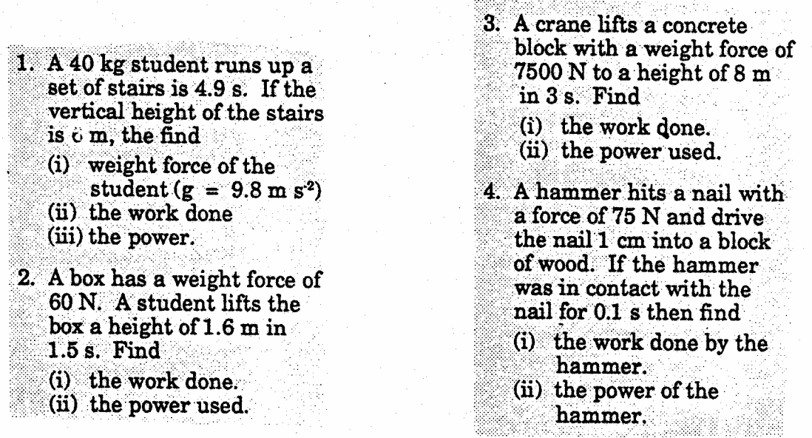

ACTIVITY 3: HOW MUCH POWER DO YOU EXPEND WHEN CLIMBING THE STAIRS NEXT TO THE POND ?

Use the technique from Activity 2 to find how much energy you use to climb the stairs.
Time how long the climb takes
Calculate power then complete the table

NAME | Mass  (Kg) | F_{w}  ₍N)  Fw=mxg | Height of stairs  (m) | Energy expended (Work done) (J)  E=mxgxh | Time taken  (s) | Your power rating (W)  P=E/t

REVISION

1 Define 'vector' and give examples.
2 What is the resulting displacement of a run of 52m south followed by a run of 164m due south.
3 What is the resultant displacement if a ball is dropped from a building 25m high onto the ground, bouncing vertically upwards and caught 2m above the ground.
4 An athlete, commencing at a point due east, completes half a lap of a circular 440m track in 25s. Determine the athlete's:
(a) average speed.
(b) average velocity (in a westerly direction).
(c) average velocity if the athlete completes one full lap at the same pace.
5 Find the initial velocity of a body which is accelerated at 1.5ms-2 for 8s to a velocity of 16ms-1?
6 A truck travelling at 6ms-1 accelerates at 1.5ms-2. What would its velocity be after 12s ?
7 Determine the distance required for a car to accelerate from rest to 72kmh-1 in 20s.
8 A can of paint falls from the top of a painter's ladder. If it takes 1.2s for the can to strike the ground below, find the:
(a) final velocity of the can
(b) length of the ladder (assumed to be vertical)
9 A cricket ball is hit vertically into the air. The ball at its maximum height is momentarily at rest and from this position takes 2.5s to strike the ground. What height did it reach ?
10 On the graph below sketch a set of 4 ticker tape drag strips for each of the following motions:
(a) constant velocity,
(b) constant acceleration and
(c) varying velocity.

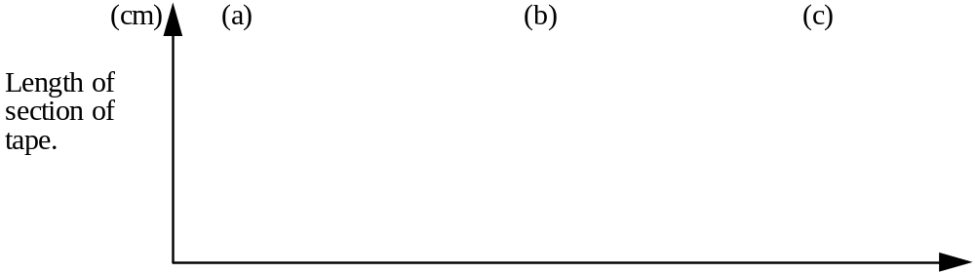
11 A mass of 9kg at rest is acted on by a force of 16.2N. How far will this mass move in 10s ?
12 What force is required to bring to rest in 3s a 1000kg body moving at 15ms-1 ?
13 A mass of 28kg is brought to rest by a force of 98N in 13s. What was the mass’s initial velocity?
14 What force is needed to move a 500kg car with an acceleration of 4m/s2 ?

15 A block of wood sliding down an incline is brought to rest in 2s by a retarding force of 0.75N in a distance of 1m. Find the :
(a) average velocity
(b) initial velocity
(c) acceleration
(d) mass of the block
16 What work is done to move a body 19.6m horizontally against a 15N resistance force ?
17 Find the work needed to move a body 15m horizontally against a 9.8N frictional resistance force?
18 What work is done when a 4.9 kg body is accelerated at 2ms-2 for 2.5m ?
19 What work is needed to lift a 20kg body 5m vertically ?
20 A car brakes suddenly and the passengers are thrown forward. Explain this phenomenon and to which of Newton's Laws it corresponds.
21 Why would a bomber release its bombs before it reaches the target ?
22 Explain the old party trick of pulling the table cloth out from under the glasses, cutlery and crockery, without dislodging them. What special features would enhance the success of this trick ?
23 In questions 10-12 what is the name given to the property that matter exhibits in each of these instances ?
24 How would the behaviour of a pendulum be explained ?
25 In terms of Newton's first law define force.
26 Newton's first law implies that:
Stationary objects normally tend to (move / remain stationary)
Moving objects should normally (maintain their velocity / slow to a stop)
If the motion of an object changes, the change is caused by (balanced / an unbalanced) force acting on it.
27 What is Newton's second law ?
28 Whenever you drop something, which of Newton's laws is operation ?
29 When two objects of different masses are released at the same time, what happens ? Explain.
30 Give three examples of action and reaction forces.
31 Explain how a rocket is propelled.

Answers: 1) Vectors are physical quantities that have magnitude and direction. Eg: displacement, velocity, acceleration, force. 2) 216mS; 3) 23m down; 4) 8.8m/s, 5.6m/sW, 0m/s; 5) 4m/s; 6) 24m/s; 7) 20m/s,1m/s2, 200m; 8) 12m/s, 7.2m; 9) 31.25;
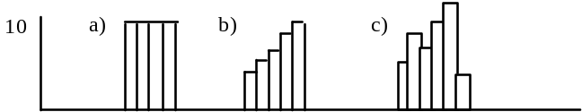
11) 90m; 12) -5000N; 13) 45.5m/s 14) 0.5m/s,1m/s,-0.5m/s,1.5kg; 15) 4m/s2, 2000N 16) 294J; 17) 147J; 18) 24.5J; 19) 1000J; 20) They continue to move forward until a force acts on them. 1st law 21) After the release the bombs continue to move forward although the force of gravity is pulling them down. 22) The inertia of the things on the table causes them to remain at rest. Friction should be reduced to a minimum. 23) Inertia is the property of objects to resist a change of motion. 24) The inertia of the pendulum bob carries it up until gravity pulls it back. 25) A force is that which changes a body’s state of rest or its uniform motion in a straight line. 26) remain stationary; maintain their velocity; unbalanced. 27) When an unbalanced force acts on a body it produces an acceleration in the direction of the force. 28) 2nd law; 29) Masses hit the ground at the same time because they have the same force (gravity) acting on them. 30) a swimmer’s tumble turn; propelling a skateboard; rocket propulsion; 31) Molecules are ejected from the back causing an unbalanced force at the front of the rocket which propels it forward.

MORE REVISION Use g=9.8m/s-2

1 A body moves 15m in 2s. What is its average speed?
2 A body moves 15km in 0.3h. What is its speed in ms-1 ?
3 A car accelerates from rest to a speed of 50ms-1 in 2.5s. What is its acceleration ?
4 A trolley is brought to rest from a velocity of 60ms-1 in 4s. What is its deceleration ?
5 An object is released from the top of a building and reaches the first floor after 4.5s. What is its speed at this point.
6 A ball is thrown down with a velocity of 20ms-1 from the top of a building, and reaches the ground 6s later. How high is the building ?
7 A ball is thrown vertically upward with a speed of 40ms-1.
(a) How long will it take to reach its maximum height ?
(b) What is the maximum height reached ?
8 The following data is from the motion of a car.
t(s) | 1 | 2 | 3 | 4 | 5 | 6 | 7 | 8
v(m/s) | 0 | 10 | 20 | 20 | 20 | 30 | 30 | 10

(i) When was it (a) accelerating ? (b) decelerating ? (c) have zero acceleration ?
(ii) What is the value of the acceleration after 2s ?
(iii) What is the value of the deceleration ?
9 A ball is projected vertically upwards and returns to its starting position 6 seconds later. How high would the object be at its maximum height ?

10 The following ticker timer tapes were produced by trolleys in motion.

Tape A : Period (time between each dot) is 0.1second.

Tape B : Period (time between each dot) is second.
For each tape (i) describe its motion
(ii) find the average velocity
(iii) find the acceleration

11. The graph below represents the motion of a vehicle:
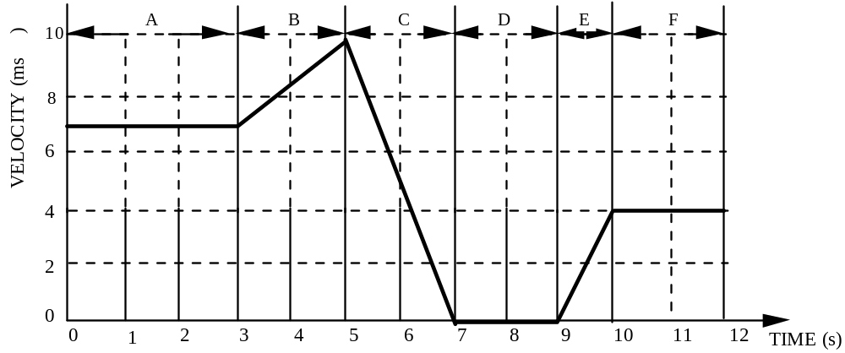
Determine:
a) The section/s in which the vehicle was stationary.
b) The section/s in which the vehicle was travelling at constant velocity.
c) The section/s in which the vehicle was uniformly accelerating.
c) The section/s in which the vehicle was uniformly decelerating.

12. The following information describes the motion of a car in heavy traffic.
a) Initially it travels at a constant velocity of 15m/s for 2 seconds and then decelerates at 5m/s for 1second.
b) It continues to travel at this new velocity for 2 seconds before having to brake to a complete stop in 1 second.
c) After remaining stationary for 1 second the car then accelerated at 2m/s for 5s and continued finally at constant velocity.

Plot this information on the graph below.
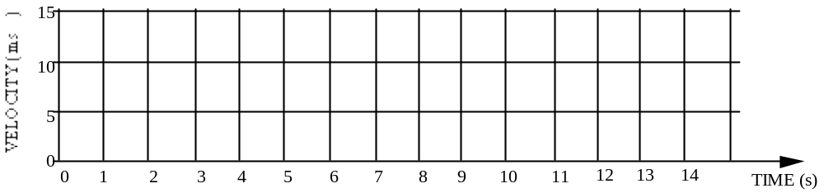

Answers: 1) 7.5m/s, 2) 13.89m/s; 3) 20m/s; 4) 15m/s2; 5) 45m/s; 6) 300m; 7) 4s, 80m; 8) t=1 to t=3 and t=5 to t=6, t=7 to t=8, t=3 to t=5 and t=6 to t=7, 10m/s2, -20m/s2, 45m; 9) constant velocity, 4.7cm/s, 0, uniform acceleration, 75.5cm/s, 625cm/s2; 11 a) D b) A,F, c) B,E d) C
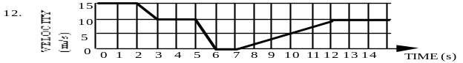
11.0 DISPLACEMENT OF UNIFORMLY ACCELERATED BODIES

11.1. We can find the displacement of a moving body by using: s = vav x t ,

For an accelerating body:
vav = v + u and so s = v + u (as v = u + at , substitute for v)
2 t 2

s = (u + at) + u (multiply both sides by t)
t 2

s = ut +at 2+ut
2

s = ut + 1at2
2

Example 1
1 A vehicle travelling at 10ms-1 is accelerated at 4ms-2. After a period of 5s, determine the:

(a) displacement
(b) final velocity
(c) average velocity

(a) u = 10ms-1 s = ut + 1at2
a = 4ms-2 2
t = 5s = (10 x 5) + 1 [ 4 x (5)2]
2
= 50 + 1 (4 x 25)
2
= 50 + 50

= 100m

Displacement is 100m in the direction of the initial motion.

(b) u = 10ms-1 v - u = at
a = 4ms-2 v - 10 = (4 x 5)
t = 5s v - 10 = 20
= 30ms-1

The final velocity is 30ms-1 in the direction of the initial motion.

(c) s = 100m vav = s or vav = v + u
t = 5s t 2

= 100 = 30 + 10
5 2
= 20ms-1 = 20ms-1

The average velocity is 20ms-1 in the direction of the initial motion.

11.2 EXERCISES

1 A car moving with a velocity of 20ms-1 is accelerated at 3ms-2. After 8s determine the:
(a) displacement
(b) average velocity
(c) final velocity

2 What distance will a cyclist travel if when starting from rest the cycle is accelerated at 1.8ms-2 for 4s ?

3 A motor boat moving with a velocity of 2ms-1 is accelerated at 1ms-2 for 6s. Calculate the:
(a) displacement
(b) final velocity
(c) average velocity

4 A train, initially at rest, leaves a railway station with an acceleration of 0.4ms-2 for a period of 50s. Find the:
(a) displacement
(b) final velocity
(c) average velocity

5 A truck travelling at 15ms-1 brakes uniformly at 1.75ms-2 for 4s in coming to rest at a stop sign. At what distance from the sign did the truck commence braking?
6 A ball starting from rest rolls down an inclined plank with an average acceleration of 5ms-2. If it takes 2s to roll off the end, determine the:
(a) length of the plank
(b) final velocity of the ball
(c) average velocity of the ball

7 A bicycle moving at 8ms-1 is accelerated at -1.25ms-2 for a 6s period. Determine the:
(a) displacement
(b) velocity at the end of this period.

8 A body with a speed of 50ms-1 is subjected to a uniform retardation of 10ms-2 for 4s. Determine the:
(a) distance travelled
(b) average speed
(c) final speed

9 A plane can effect take-off with a velocity of 72ms-1. If the plane can accelerate along the runway at 4ms -2 determine the:
(a) time taken to reach a speed of 72ms-1
(b) minimum length of runway to enable a safe take-off

10 A person starting from rest takes 6s to reach a maximum velocity down a ski slope. Assuming a constant acceleration of 5ms-2 find the:
(a) distance travelled in 6s
(b) maximum velocity attained by the skier

11 A car is accelerated from 17ms-1 to 44ms-1 in 18s. Calculate the:
(a) average velocity
(b) acceleration
(c) displacement in this period.

12 Determine the displacement of a vehicle accelerated from rest at 2ms-2 in a time of 6s.
13 How far will a plane travel before lift off occurs, if it takes 25s,starts from rest and accelerates at 2.8ms-2 ?
14 A car travelling at 42ms-1 can be stopped in 7s. Find the:
(a) acceleration
(b) minimum distance required to stop the car.

Answers: 1) 256m, 32m/s, 44m/s; 2) 14.4m; 3) 30m; 8m/s 5m/s; 4) 500m, 20m/s, 10m/s; 5) 46m; 6) 10m,10m/s, 5m/s; 7) 25.5m, 0.5m/s; 8) 120m 30m/s, 10m/s; 9) 18s, 648m; 10) 90m,30m/s; 11) 30.5m/s, 1.5m/s2, 549m; 12 36m; 13) 875m; 14) -6m/s2, 147m.

12.0 GRAVITATIONAL ACCELERATION
12.1. All freely falling bodies close to the earth's surface are accelerated at the same rate, 9.8ms-2, ( i.e., they fall the same distance in the same time) in a vertically downward direction.
The acceleration due to gravity is often referred to as g.
It has the units ms-2 but can also have the units N/kg.

Our equations of motion become:

g = or the version more frequently used: v-u = gt ( with g = 9.8ms-2)

s = ut + 1 gt2 2

NOTE The effects of air resistance are ignored and are assumed to be negligible.

Example 1:

1 A stone falls off the edge of a cliff. If it takes 6s to strike the ground below, determine the:
(a) velocity with which the stone strikes the ground.
(b) the height of the cliff.

(a) u = 0 v - u = gt
t = 6s v - 0 = (9.8 x 6)
g = 9.8ms-2 = 58.8 ms-1
v = ?

The stone strikes the ground at 60ms-1( downwards)

(b) u = 0 s = ut + 1gt2
t = 6s 2
g = 9.8ms-2 = 0 + 1 [9.8 x (6)2]
s = ? 2
= 1 ( 9.8 x 36)
2
=176.4m
The displacement is 176.4m (downwards) so the height of the cliff is 176.4m.
12.2. EXERCISES

1 A stone is thrown vertically downwards at 10ms-1 . After 2.5s, fine the:
(a) velocity.
(b) displacement

2 A ball is thrown vertically downwards into a well with a velocity of 15ms-1 . If the time taken to strike the water is 1s find the:
(a) velocity with which the stone strikes the water.
(b) depth of the well to the water level.

3 A bullet is fired vertically upwards at 600ms-1. What is the velocity of the bullet after:
(a) 20s
(b) 100s

4 A ball is thrown vertically upwards at 13ms-1 . What is its velocity after 1.6s ?

5 A bullet is fired vertically upwards at 600ms-1 . Determine the:
(a) time taken for the bullet to reach the maximum height
(b) height reached by the bullet.

6 A stone is thrown vertically upward at 16ms-1. Calculate the:
(a) time taken to reach maximum height
(b) height reached by the stone,

7 A brick falls from rest off the top of a construction site.
(a) How far does it fall during the first second?
(b) How far has it fallen after 2 seconds have passed.
(c) How far does it fall during the second(2nd) second?

8 An object is thrown vertically upward at 17.2ms-1 , How long will it take for the object to return to the ground ?

Answers: 1) 34.5m/s downwards, 55.625m downwards; 2) 24.8m/sdownwards, 19.9m downwards; 3) 404m/s upwards, 380m/s downwards; 4) -2.68m/s; or 2.68m/s downwards; 5) 61.2s, 18352 m or 18.352 km upwards; 6) 1.6s, 13.1m 7) 4.9m downwards, 19.6m downwards, 14.7m; 8) 1.76s x 2 =3.52s.

